MOVE IT!
Today you will find out how:
- push or pull forces will make an object move
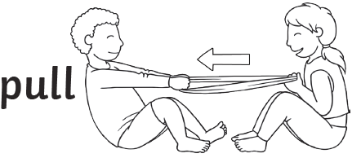
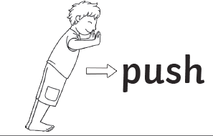

Let’s tune in.

- Watch these clips.
- Watch them lots of times.
https://www.youtube.com/watch?v=dj27RwnUopQ
https://www.youtube.com/watch?v=HCvbN2P_MCY

Activity
- Write the title MOVE IT
- Write the date
- Write three facts you learnt into your workbook.
_________________________________________________
This is a push. This is a pull.

MOVE IT!

Push and Pull in different environments.
- Go to the school website.
- Open the POWERPOINT called Push and Pull.
Activity -
- As you watch make a list of all the pushes and pulls you see.
Example- pulling the door.

- NEXT, draw a table with enough room for your answers
Push | Pull

- Sort your list into the right column
- Draw a picture to match.

