WEEK 5 FRIDAY GRADE 1/2A MATHS COMMON TASK – 2D SHAPES NAME:
THIS NEEDS TO BE DONE BY YOURSELF
Completed by: WEEK 5 FRIDAY 15TH MAY
Email to: torchia.adam.d@edumail.vic.gov
This week we are looking at 2D shapes. Can you fill in (as much as you can) the blanks on this table?
Picture of the shape | Name of the shape | How many sides? | How many corners? | Finding this at home (take photos or drawings)
 | Circle |  | 0 corners
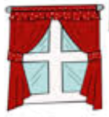 | Square
 |  | 3 sides | 3 corners
 |  | 4 sides
 | Hexagon
Picture of the shape | Name of the shape | How many sides? | How many corners? | Finding this at home (take photos or drawings)
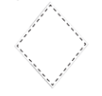
 | Octagon |  | 8 corners
 |  | 5 sides

Can you think of any 2D shapes we forgot? Write them here:

