Growth Mindset
Learning Intention: We are learning the difference between a fixed mindset and a growth mindset
Success Criteria: I can reflect on a time when I used a growth mindset.

Watch the ClickView Miniclip Growth Mindset https://clickv.ie/w/m7Om
This is a story of two seeds – both planted on the same day, in the same soil, in the same garden bed. One has a growth mindset—with a curious desire to grow and reach the outside world—while the other has a fixed mindset—filled with fear and choosing the remain stagnant in its soil.

We would like you to reflect on a time when you tried something new:
• Were you scared before you tried it?
• Did you fail or do worse than you hoped initially?
• Are you better/more confident about it after trying?

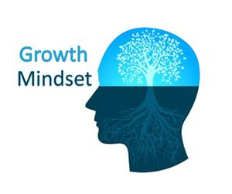
Write in a paragraph below describing your reflection.
This Photo by Unknown Author is licensed under CC BY-SA-NC

