Hello 5-6 Parents and Students!
Hope you are enjoying the sport sessions each week. Reminder to take photos of you completing the session and sending it through Flexibuzz. In the P.E/Sport Box so I can see it, please have your name on it as well!
Also, I highly recommend every student is spending at least 60 minutes of their day being physically active in one way or another. I have put a word document on Flexibuzz with heaps of different activities you can do.
Any questions, just message me on Flexibuzz or email.
Mr J
P.E Coordinator.
Week 4: Ground Level Target game – Bowls Maze
Last Week, we looked at Ten Pin Bowling as a ground level target game. This week we are looking at Bowls. You may have played it before!
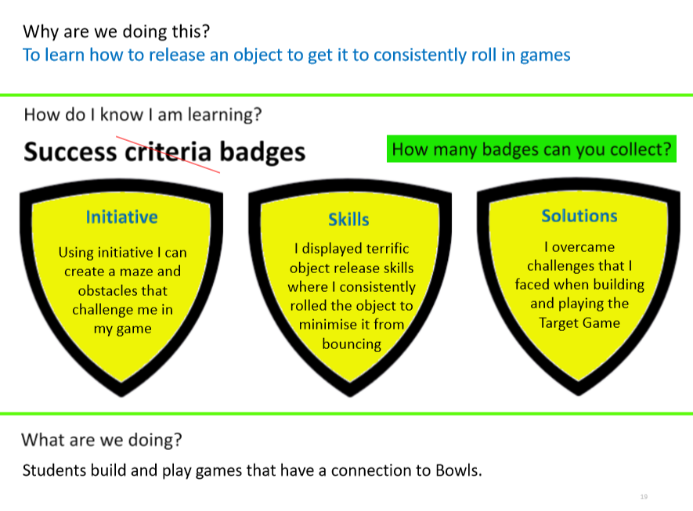
Bowls is a game where you roll the ball to another ball and have to make it stop as close as possible to the target. The person who has their ball closest to the target ball wins. If you research Lawn Bowls – some examples of the game will come up

Activity 1: Bowls Maze
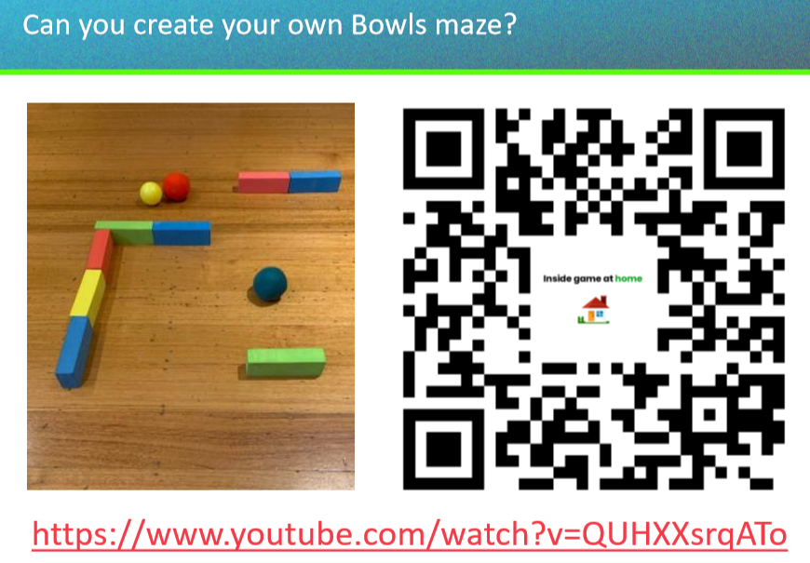
The Youtube link goes to a P.E teacher creating a bowls maze as an example. Create your own and test it out!

https://www.youtube.com/watch?v=QUHXXsrqATo

Draw your bowls maze below from a birds eye view, or use the photo your parents took!

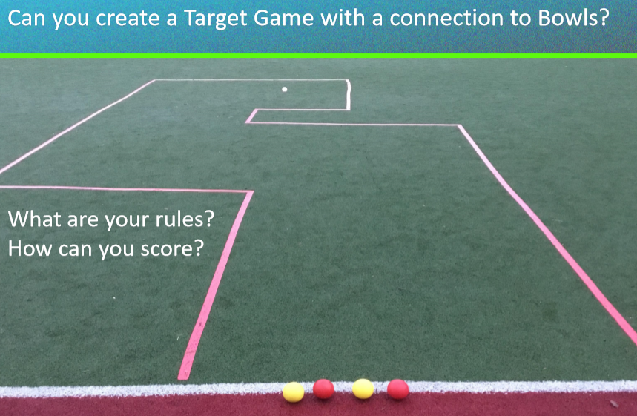
Activity 2: Creating a target game with Bowls

Build your own Lawn bowls game. It is ok if you just play Lawn Bowls!
What equipment are you using?

What rules do you have for this game?

How far away from your target?

What skill are you using in this game?
Draw your game here! Or place the photo your parents have taken of you

