Merhaba Çocuklar! HelloChildren!
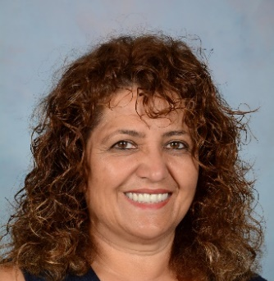
In Turkish, we are learning the names of the Seasons and a song called “Mevsimler” – Seasons.
Activity 1:
- Please click on the flowing link to see pictures of the seasons matching with their names.
https://www.youtube.com/watch?v=tbU_7jszkQ8
- Now listen to the names of the seasons in Turkish
from the voice recording on the left hand side.
Please click here to listen
MEVSİMLER ...... SEASONS Renkler/Colours
İLKBAHAR ...... Spring Yeşil
YAZ ...... Summer Kırmızı
SONBAHAR ...... Autumn Sarı
KIŞ ....... Winter Beyaz

Activity 2: Please click on the following link to listen to the Mevsimler - Seasons song and sing along by looking at the lyrics for your enjoyment.
Challenge: Try to memorise your favourite part of this song.
https://www.youtube.com/watch?v=nzLJdaxhHqc
Mevsimler (Şarkı) Seasons (Song)

Hep yeşildir elbiselerim.  Bu rengi ben pek çok severim.  İlkbaharı cicim,  Çok sevdiğim için.  Hep yeşildir elbiselerim.  Hep kırmızıdır elbiselerim.  Bu rengi ben pek çok severim.  Yaz mevsimini ben  Çok sevdiğim için.  Hep kırmızıdır elbiselerim.  Hep sarıdır elbiselerim.  Bu rengi Ben pek çok severim.  Sonbaharı ben  Çok sevdiğim için.  Hep sarıdır elbiselerim.  Hep beyazdır elbiselerim.  Bu rengi ben pek çok severim.  Kış mevsimini ben  Çok sevdiğim için.  Bu rengi ben pek çok severim. | My clothes are always green.  I like this colour very much.  My dear,  Since I like Spring so much  My clothes are always green.  My clothes are always red.  I like this colour very much.  My dear,  Since I like Summer so much  My clothes are always red.  My clothes are always yellow.  I like this colour very much.  My dear  Since I like Autumn so much  My clothes are always yellow.  My clothes are always white.  I like this colour very much.  My dear,  Since I like Winter so much  My clothes are always white.

Activity 3: Fill in the table following by watching the Mevsimler Song video clip again as in the example.

Name of the Seasons in English | Name of the Seasons in Turkish | The names of the items for that season | Draw and colour the item
Spring | İlkbahar | Elma  Salatalık  Erik

