Hello 1-2 Parents and Students!
Hope you enjoyed the first week of your sport sessions. Reminder to take photos of you completing the session and sending it through Flexibuzz. In the P.E/Sport Box so I can see it, please have your name on it as well!
Also, I highly recommend every student is spending at least 30minutes of their day being physically active in one way or another. I have put a word document on Flexibuzz with heaps of different activities you can do.
I encourage 1-2 students if they have older brothers or sisters to join in with their P.E Session.
Please send your work to me! Photo proof you doing the activity, either by email or Flexibuzz
Jordanidis.andreas.a@edumail.vic.gov.au
Mr J
P.E Coordinator
Week 6: Target Throwing.
Now that we have been doing a few weeks of throwing, we are going to do some target throwing. You can do either underarm or overarm for this. Think about which one is best!
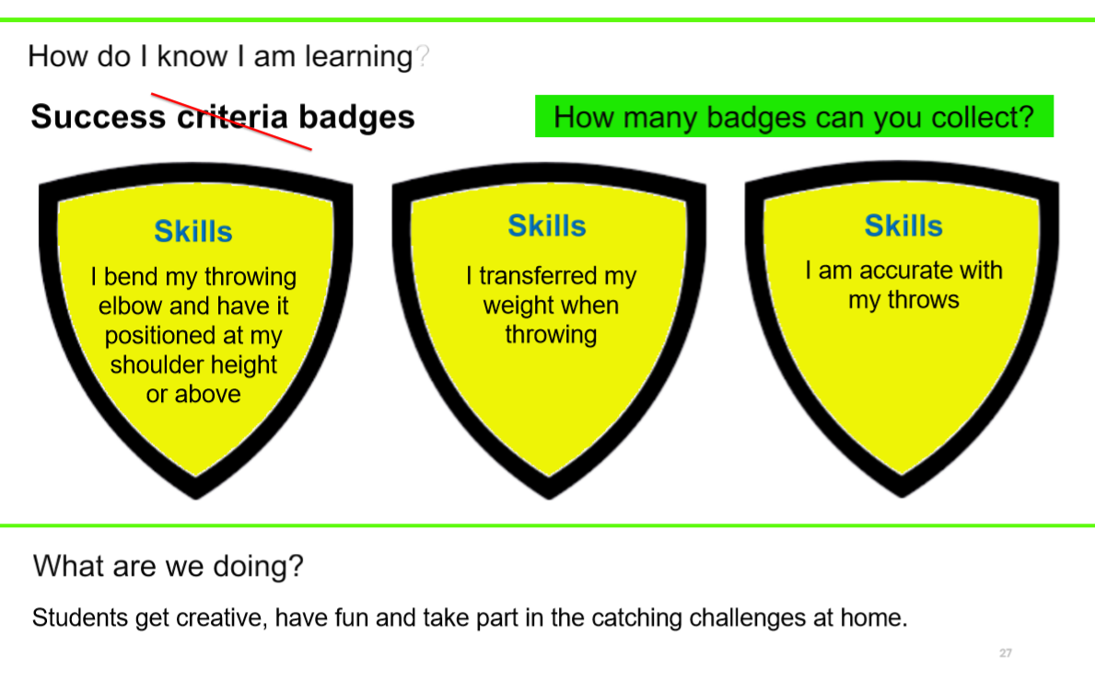
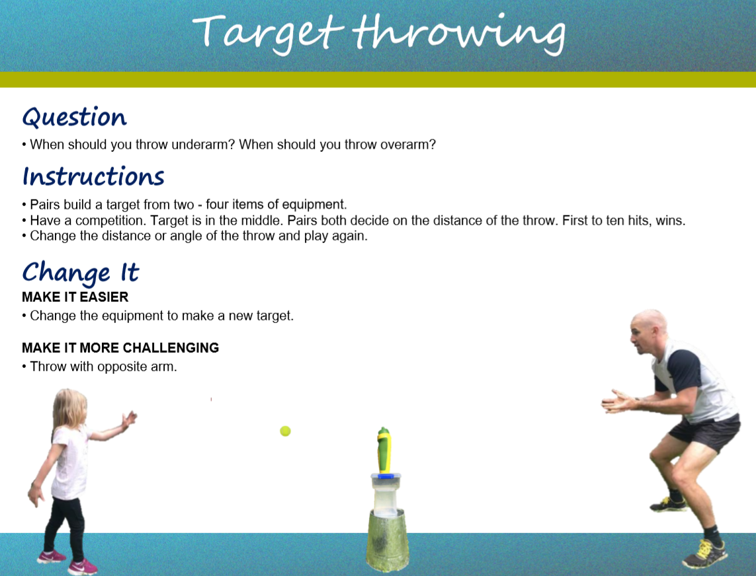
Activities

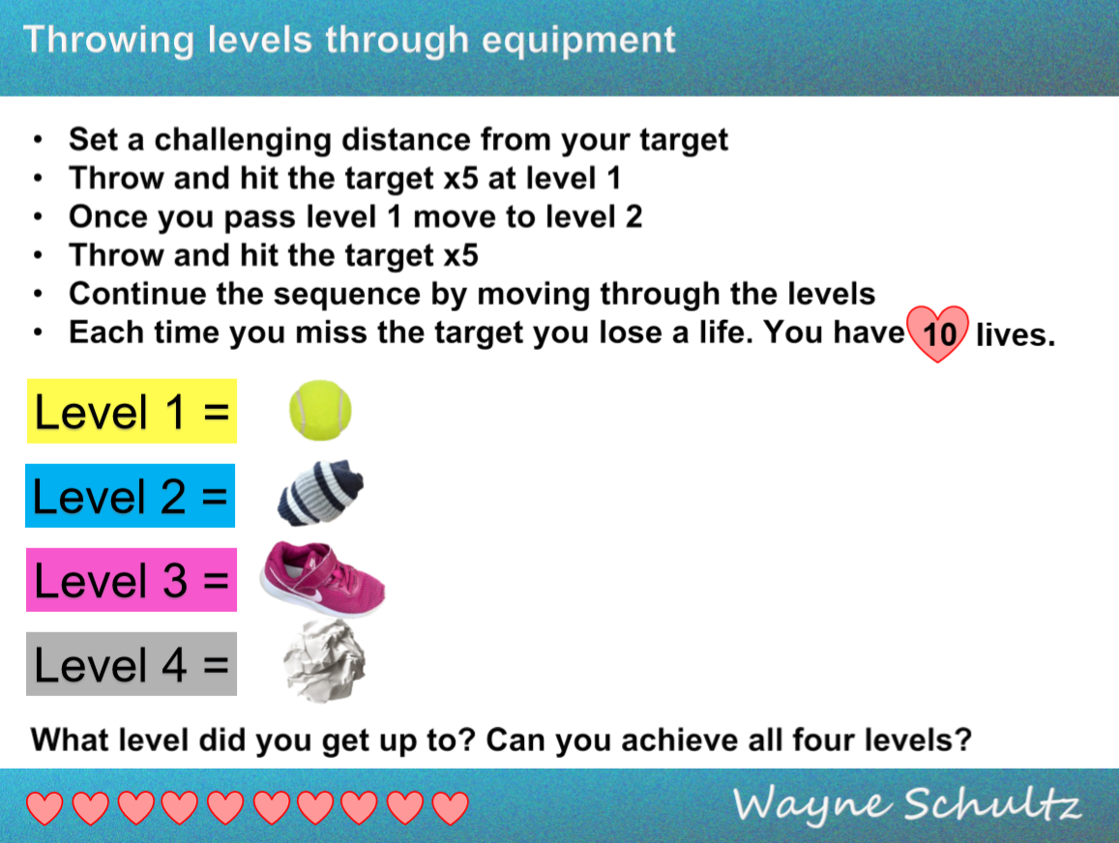

Your Target can be anything – I suggest a basket, bin, drawing a circle on the wall, a water bottle, a bucket. So many options!

Challenge a family member! Who will win?!

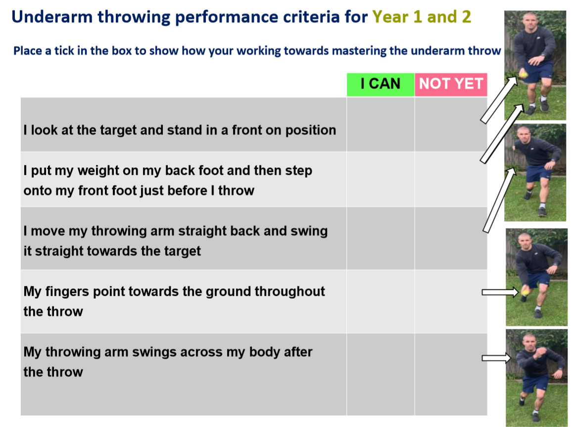
Write the date and fill out how you are going with your throwing!

