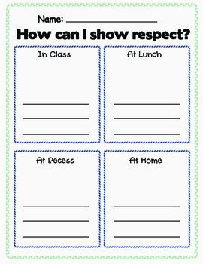
At Home
At Recess
At Lunch
In class

How can I show Respect?
Respect Song
https://www.youtube.com/watch?v=TmRjyQlWyQg
Respect on the Playground
https://www.youtube.com/watch?v=k-6ws8LZECU

