

**MEADOW HEIGHTS PRIMARY SCHOOL**

NEWSLETTER5 JUNE 2023

Week 7

Week

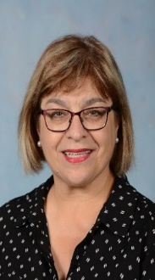

*We respectfully acknowledge the Traditional Owners of country*

*throughout Victoria and pay respect to the ongoing*

*living cultures of First Peoples.*

Principal, Margaret Leach

**Dear Parents and Carers**

Have you noticed the new school signs?

These new signs have more than one purpose as the signs not only inform visitors the direction to go to find different areas in the school, but they also reaffirm our school values. We aim to make our values the way we live in our school community.

|  |  |  |
| --- | --- | --- |
| **RESPONSIBILITY** | Be responsible | Responsible for your behaviour, be trusted and show common sense. |
| **EXCELLENCE** | Be excellent | Set a high standard and always trying to do the best you can. |
| **RESPECT** | Be respectful | Showing care and consideration for the feelings, rights or needs of others. |
| **PRIDE** | Be proud | Being proud of who you are and what you do, having a sense of belonging to the MHPS Community. |

**WINTER IS HERE**

Now that we are officially in winter just a friendly reminder for children to have a warm jacket for when they go outside, a warm hat and gloves are a bonus.

**PARENT TEACHER MEETINGS**

Many thanks to all parents who have responded and booked an interview to meet their child’s teacher on Wednesday the 21st of June. If you have not done so as yet please contact your child’s teacher who is keen to share your child’s learning journey with you.

Have a great week!

**Warm regards**

**Mrs Margaret LEACH**

**School Principal**



**IMPORTANT DATES**

**DAY DATE ACTIVITY**

**JUNE 2023**

**Tuesday 6 Parenting in the Digital World, Parent Info**

**Session, 2.30pm - Media Centre**

**Friday 9 Prep - Grade 2 – Assembly in the Hall 2.35pm**

**MONDAY 12 PUBLIC HOLIDAY – NO SCHOOL**

**Friday 16 Grades 3 – 6 – Assembly in the Hall 2.35pm**

**Wednesday 21 Parent Teacher Interviews**

**Friday 23 NO ASSEMBLY**

**Friday 23 Last Day of Term II – Bell rings 2.30pm**

**JULY 2023**

**Monday 10 Term III commences – 8.50am**

**HAVE YOU CHANGED YOUR DETAILS?**

Please immediately notify the School Office of

any changes to your address or contact details. Please update your email address for COMPASS information.

**Office Hours**

Monday—Friday

8:30am to 4:00pm

Last day of each Term the office will close at 2:30pm

***The office is CLOSED during all school holiday periods***

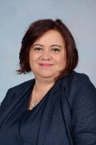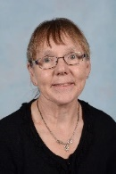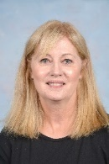

**Some Tips from the MHPS Wellbeing Team**

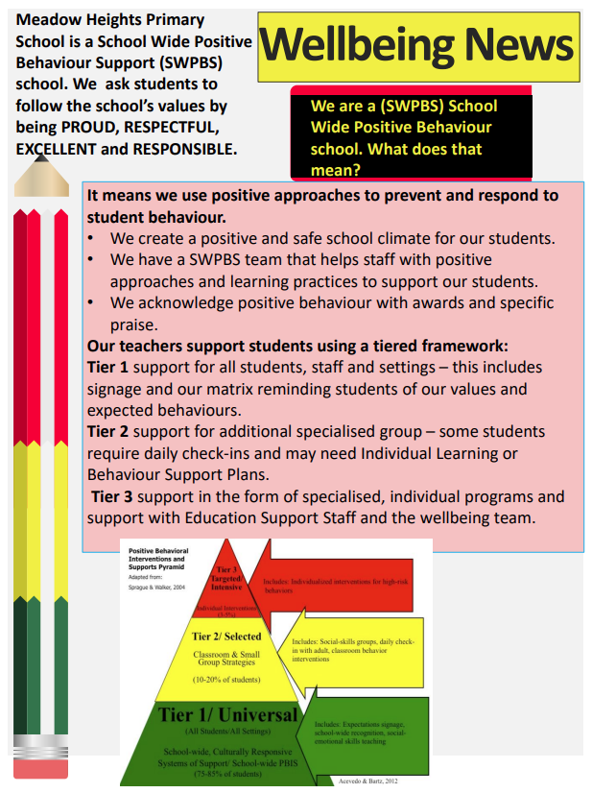

**LIBRARY NEWS**

*Dear Parents/Caregivers,*

*Your child/ren come to the school Library every week. Please ensure that they return their Library books every week so that they can borrow or reborrow. We have lots of new books! The following timetable indicates which day each class has their Library session.*

|  |  |  |  |  |  |  |  |
| --- | --- | --- | --- | --- | --- | --- | --- |
| **MONDAY** | | **TUESDAY** | | **WEDNESDAY** | | **THURSDAY** | |
| **PA** | **MS CARRONDO** | **PB** | **MS HAYEK** | **PC** | **MRS CROUCH** | **1B** | **MS PENNINI** |
| **34E** | **MRS DURNA** | **1C** | **MRS ROFAEL** | **1A** | **MRS KOVACEVIC** | **2A** | **MR LA MATTINA** |
| **56D** | **MS CARUSO** | **34A** | **MS PIRRO** | **2B** | **MS O’CONNELL** | **34D** | **MRS BELL** |
|  |  | **34B** | **MS PARKIN** | **2C** | **MS DELANEY** | **56B** | **MS LANG** |
|  |  | **34C** | **MR KNOX** |  |  |  |  |
|  |  | **56A** | **MR PACE** |  |  |  |  |
|  |  | **56C** | **MS ISDAR** |  |  |  |  |

*Thank you for your assistance.*

*The Library Staff*

**OUR MAY ATTENDANCE STARS**

**90%+ Attendance for the month of May**

|  |  |  |
| --- | --- | --- |
| PA – Ms Carrondo | PB- Ms Hayek | PC- Mrs Crouch |
| Hassan A Hanan E  Muhammad J Ghazel O  Noah S Salahadin S  Reema S Lavannah T  Lorena W Adam W | Zoya A Issa A  Lucas A Semih B  Mason F Bareera K  Sarah K Lance M  Joseph M Rima M  Odyssey P Angel S  Aiman S Amir W | Hussein A Husniye T  David A Lana Y  Adam Al Anastasia Y  Marwan E Marwa E  Maryam H Zena L  Carlos M Jordan N |
| 1A – Mr Torchia & Mrs Kovacevic | 1B – Ms Rosy | 1C – Mrs Rofaeel & Ms Marks |
| Haniya A Noah B  Hamza E Sulaiman I  Roukaya J Oguzhan K  Chantelle M Mohammed O  Mahmoud O Isabel Q  Eslem S | Rickan A Isaac A  Atahan A Fatima A  Stavrou A Zyad D  Yusuf E Sofiya J  Angelo K Noah M  Aneesa M Marcelino Q  Zak R | Ibraheem A Argane A  Hasan A Elif B  Alara D Aesha E  Akhmed E Muhammad E  Hussein H Hannah K  Illiya Z |
| 2A – Mr La Mattina | 2B – Ms O’Connell | 2C – Mrs Delaney |
| Masoud A Sumeya J  Daniel M Yahya M  Mira M Rimona Q  Osman T Esmanur Y  Nicholas Y Tura Y  Oscar Z | Aya A Nora A  Elif B Melisa B  Hiba E Khaled H  Zohan H Kayra K  Ertugrul K Yara S  Zara S Fatima Y | Veronika A Freya A  Asrin B Beyza D  Esmanur E Meryem E  Reem E Adnan J  Zarak K Salmaan S  Uday W |
| 3/4A – Ms Pirro | 3/4B – Ms Parkin | 3/4C – Mr Knox |
| Ma’Awa A Rehan A  Safoora A Nihal A  Aaron A Sara A  Omid A Efe B  Dilan D Salwa E  Zara E Hinata H  Tomas K Ata K  Muhammed K Hafeez M  Yusuf S Omer T  Mary W Iskandar Z | Hanan A Nawal A  Nesreen A Aleena B  Ali C Israa E  Maria G Teeyana I  Tala J Amir M  Adnan M Natalie O  Zisan T Khaled W | Ehaan A Elif A  Aya A Ayda A  Aqil E Khattab E  Zaccy E Metiyus G  Rayyan H Murat K  Chantelle L Jaisen N  Rayan S Hassan S |
| 3/4D – Mrs Bell | 3/4E – Mrs Durna | 5/6A – Mr Pace |
| Andarina A Layan A  Derin C Rami E  Abdul H Brekhna K  Muhammed K Jayden M  Kubilay O Nurgul S  Joseph Y Zeynep Y | Aisha A Nadra A  Janna A Maisam A  Talal A Maryam D  Elif D Remman J  Zarar K Momina M  Matab O Mohammed O  Charbel Q Ruqayyah R  Abdolwahab R Khadija S  Meyes T Krestean Y | Loujain A Ahmad A  Rayana A Kerim A  Kuzey E Raphael M  Eylul M Michael N  Leyla O Valentino S  Devran T Ahmad W  Natcha W Muhammad Z |
| 5/6B- Ms Lang | 5/6C – Ms Isdar | 5/6D – Ms Caruso |
| Houda A Iman E  Musab H Melek J  Nangial K Issa M  Arshia R Christy W  Pinar Y Mohamed Ali A | Sidra A Shuaib A?  Omar E Amira K  Esho K Aniaster S Abdulrahman R Sahej S  Aliza S Khaled W | Ayah A Yasmin A  Maryna A Suban E  Youssef E Ali E  Zeynep K Anjy K  Noureddin M Androo M  Ela M Merve O  Edin S Zeynep T  Alize T Dominic V  Antonio W Adnan W |

**CANTEEN NEWS**

**!!PARENTS / CAREGIVERS!!**

Please note the Canteen will be **CLOSED** at the end of term on the following dates:

Wednesday 21 June

Thursday 22 June

Friday 23 June

**Please ensure your child has a packed snack,**

**lunch and water on days the Canteen is CLOSED**

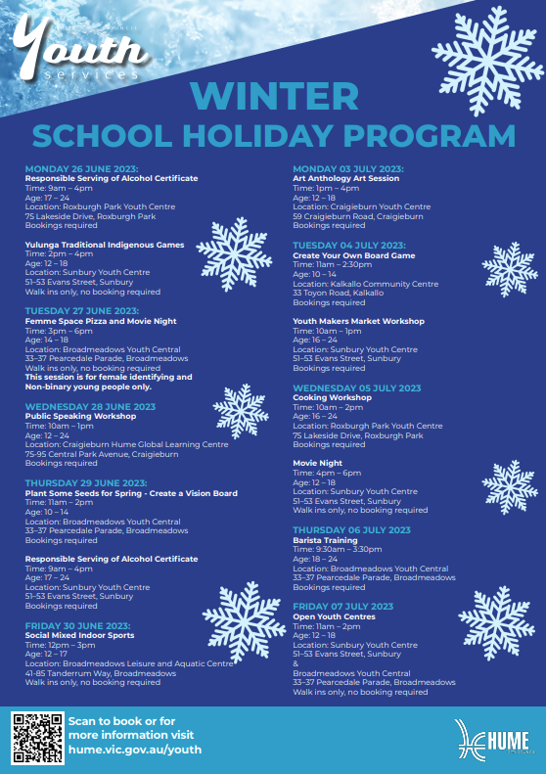

****The Wellbeing, Health and Engagement Division of the Education Department have provided the following advice.



**Stay well this winter!**

Symptoms of influenza (flu) can hit very quickly and may last several weeks. Vaccination is the best way to protect yourself and others from getting the flu.

[Annual influenza vaccination](https://www.health.gov.au/resources/publications/fighting-flu-starts-with-you-consumer-fact-sheet?language=en) is recommended from mid-April each year and is free under the [National Immunisation Program](https://www.health.gov.au/topics/immunisation/vaccines/influenza-flu-vaccine) for those at higher risk of complications from the flu.

Keeping our school community well

Parents, carers, and students are encouraged to practice prevention measures, including:

* washing and sanitising hands regularly
* avoiding touching eyes, nose, and mouth with unwashed hands
* covering nose and mouth when coughing or sneezing
* staying home if unwell and consulting a general practitioner (GP) or [Nurse-on-call](https://www.health.vic.gov.au/primary-care/nurse-on-call) as required
* staying up to date with flu and COVID-19 vaccinations.

## Flu vaccinations

Flu vaccinations can be booked through GPs and pharmacies, many of which can also provide COVID-19 vaccinations. Flu vaccination is recommended for everyone aged 6 months and over.

Some people are more at risk of complications from flu and are eligible for free vaccination as part of the [National Immunisation Program](https://www.health.gov.au/our-work/national-immunisation-program).

COVID-19 booster

The 2023 COVID-19 booster dose is available for everyone aged 18 and above.

Getting your booster dose remains the best way to prevent severe illness or hospitalisation, especially in people aged over 65 and those at higher risk of severe illness.

You can have your booster dose 6 months after your last dose or COVID infection.

Children aged between 5 and 17 years who are at risk of severe illness can also receive a 2023 booster dose.

You can get your next dose at your local pharmacy or GP. To find one near you, refer to the [vaccine clinic finder](https://covid-vaccine.healthdirect.gov.au/booking/).

Find out more

For more information about preventing flu, and immunisation, refer to:

* [Better Health Channel influenza flu immunisation fact sheet](https://www.betterhealth.vic.gov.au/health/healthyliving/flu-influenza-immunisation)
* [Getting vaccinated against influenza](https://www.health.gov.au/resources/collections/getting-vaccinated-against-influenza-resource-collection#-information-for-consumers).

## Premium Vector | School bag with pencil and book clipart educational hand drawn illustrationPremium Vector | School bag with pencil and book clipart educational hand drawn illustration

## Prep bags 2023 survey

Have your say about this year’s Prep bags in a short survey, closing Sunday 9 July

Each year, the Department of Education gives every Prep student attending a Victorian government school a bag full of goodies to celebrate this milestone in their education journey. The information and educational resources in the bags are designed to help Prep students and their families thrive from the start of Term 1.

The department is inviting parents and carers of current Prep students to participate in a short survey about the 2023 Prep bags, by 5 pm on Sunday 9 July 2023.

Your feedback will help the department learn what families liked about the Prep bags and what can be improved in 2024.

You can have your say at [2023 Prep Bags – Evaluation Survey](https://www.surveymonkey.com/r/2023PrepBags-Families).

The survey takes 5 to 10 minutes to complete, and responses are anonymous.

For more information on this year’s Prep bags, refer to [Prep bags.](https://www.vic.gov.au/prep-bags)

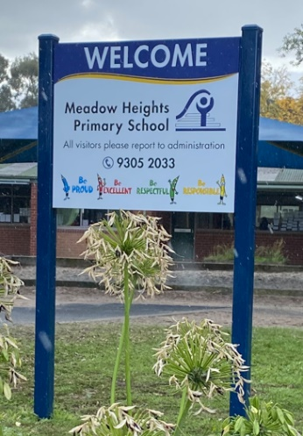**Sayın Veliler ve Bakım Sağlayıcılar,**

**OKUL TABELALARI**

**Yeni okul tabelalarını fark ettiniz mi?**

Bu yeni tabelaların birden fazla amacı var çünkü tabelalar sadece ziyaretçilere okulda farklı alanları bulmaları için gitmeleri gereken yönü bildirmekle kalmıyor, aynı zamanda okul değerlerimizi de teyit ediyor. Değerlerimizi okul topluluğumuzda yaşama şeklimiz haline getirmeyi amaçlıyoruz.

SORUMLULUK Sorumlu olmak Davranışlarınızdan sorumlu olun, güvenin ve  
 sağduyulu olun.

MÜKEMMELLİK Mükemmel ol Yüksek bir standart belirleyin ve her zaman elinizden  
 gelenin en iyisini yapmaya çalışın.

SAYGI Saygılı ol Başkalarının duygularına, haklarına veya  
 ihtiyaçlarına özen ve ilgi göstermek.

GURUR Gurur duymak Kim olduğun ve ne yaptığınla gurur duymak, MHPS  
 Topluluğuna ait olma duygusuna sahip olmak.

**KIŞ GELDİ**

Artık resmen kış mevsiminde olduğumuza göre, çocuklara dışarı çıktıklarında sıcak tutan bir ceket giymeleri için dostça bir hatırlatma, sıcak tutan bir şapka ve eldivenler de ikramiye.

**VELİ ÖĞRETMEN TOPLANTILARI**

21 Haziran Çarşamba günü çocuklarının öğretmeniyle buluşmak için bir görüşme rezervasyonu yapan tüm ebeveynlere çok teşekkür ederiz. Henüz yapmadıysanız, lütfen çocuğunuzun öğrenme yolculuğunu sizinle paylaşmak isteyen öğretmeniyle iletişime geçin.

İyi haftalar dilerim.

**Mrs Margaret Leach**

**Okul Müdürü**

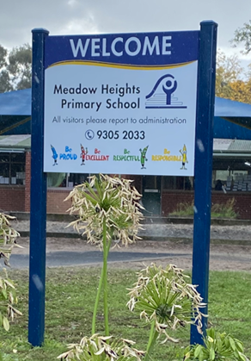أولياء الأمور ومقدمي الرعاية الأعزاء

لافتات المدرسة

**هل لاحظت لافتات المدرسة الجديدة؟**

**هذه ا**لا**فتات الجديدة لها أكثر من غرض واحد لأن الافتات لا تخبر الزائرين فقط بالاتجاه للذهاب للعثور على مناطق مختلفة في المدرسة ، ولكنها أيضًا تعيد تأكيد قيم مدرستنا. نهدف إلى جعل قيمنا بالطريقة التي نعيش بها في مجتمع مدرستنا.**

|  |
| --- |
|  |
|  |
|  |
|  |

**الشتاء هنا**

الآن بعد أن أصبحنا رسميًا في فصل الشتاء ، مجرد تذكير ودي للأطفال بارتداء سترة دافئة عندما يخرجون للخارج ، فإن القبعة الدافئة والقفازات هي إضافة.

**اجتماعات أولياء الأمور**

شكراً جزيلاً لجميع أولياء الأمور الذين استجابوا وحجزوا وقتأ لمقابلة معلم أطفالهم يوم الأربعاء 21 حزيران. إذا لم تكن قد فعلت ذلك حتى الآن ، فيرجى الاتصال بمعلم طفلك الذي يحرص على مشاركة رحلة تعلم طفلك معك .

أتمنى لكم أسبوعًا رائعًا.

**السيدة مارغريت ليتش**

**مديرة المدرسة**