Hello 5-6 Parents and Students!
Hope you are enjoying the sport sessions each week. Reminder to take photos of you completing the session and sending it through Flexibuzz or my email. In the P.E/Sport Box so I can see it, please have your name on it as well!
Also, I highly recommend every student is spending at least 60 minutes of their day being physically active in one way or another! I have put a word document on Flexibuzz with heaps of different activities you can do.
Check the video I have made to show how to do this activity. Send your work to me either by email or Flexibuzz
Jordanidis.andreas.a@edumail.vic.gov.au
Mr J
P.E Coordinator.
Week 6 Large Target Games
Large Target games, as the name suggests are games where you have a large target to aim for. Think of the throwing game we did in term 1 with the nets! It was a large target to aim for.
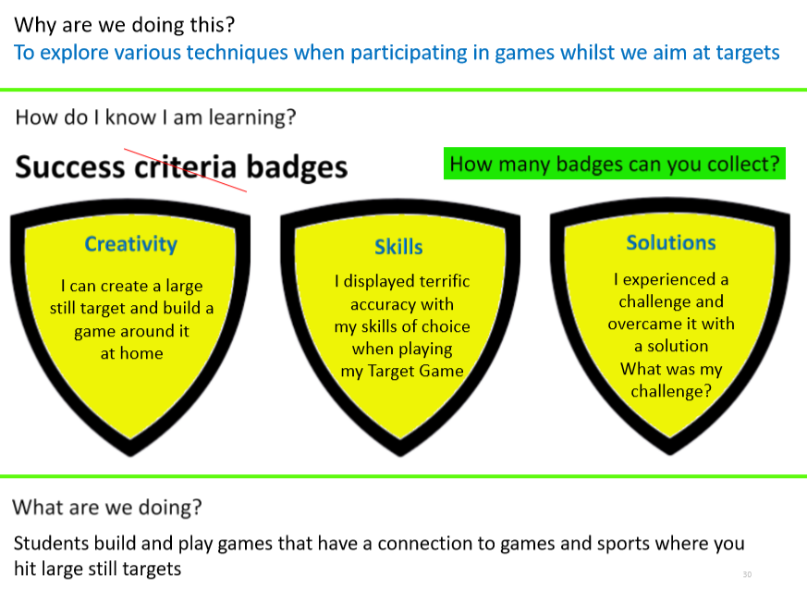

A Large target can be made from various objects in your house. Just be careful that you only use plastic items! Do not want any glass breaking when you play this game.
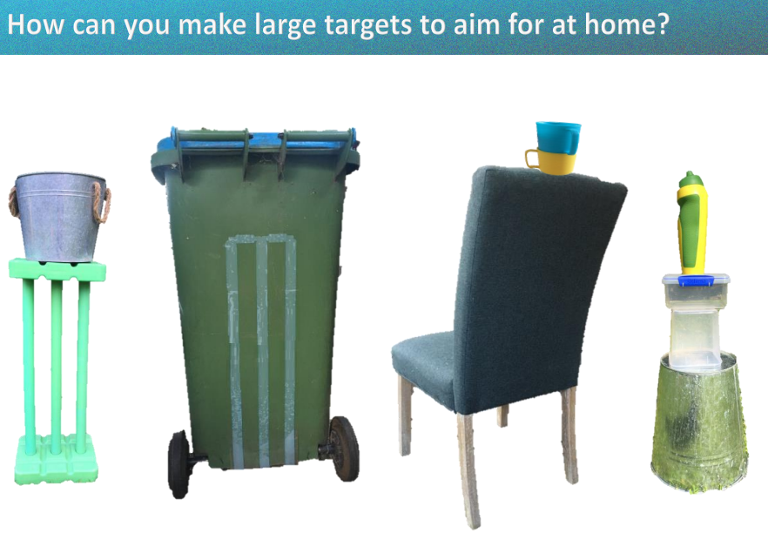

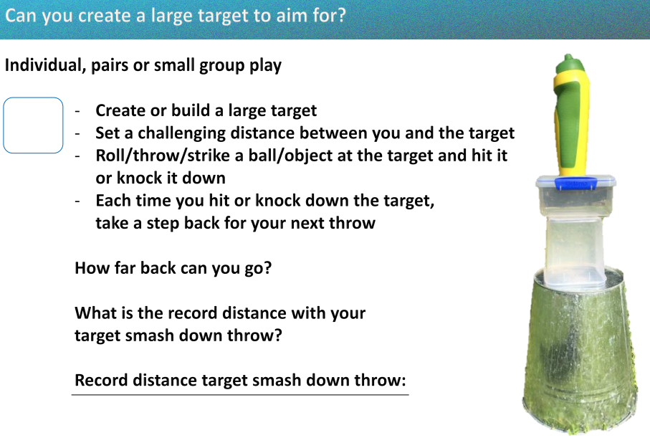
Answer these questions about the large target game you made.
Large Target Game
What equipment did you use for this game?

What are the rules?

How far back did you throw to hit your
target?

How would you change the game?
Draw and label what your large target was!

