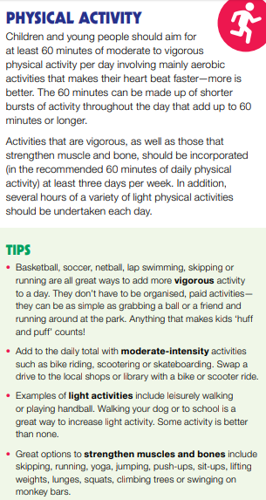
P.E At home Activities:
Grade 1/2 = Bouncing – Using a ball at home, bounce the ball back up to you. Practice dribbling the ball like in basketball.
Bounce against the wall – Throw a ball against the wall of your house OUTSIDE and catch the ball back. See how many times you can do it in a row.
Throw and Catching – With a brother/sister/mum/dad, stand apart from each other and do an underarm throw and catch to each other. If it is too easy, step backwards to make it harder.
Using any balls you can, have a play. Create a game throw the ball around.

Students are encouraged to do any physical activity they feel comfortable doing. It is a national guideline they do at least 60 minutes a day.

There are a few options listed above. You can do whatever activity you like as long as you are practicing any sport skills. Develop any of your sport skills that you want to improve on.

