Copyright disclaimer: I do NOT own any of these links or pictures featured in this document. All rights belong to it's rightful owner/owner's. No copyright infringement intended.

Fundamental Motor Skills
Miss Physical Education – Facebook – A lot of different at home games
https://tinyurl.com/y8n2wfyc
This link when typed into google will bring up a slides of different fundamental motor skills that ALL kids need to know how to do. Practice them at home. Especially Grade 1/2 students!

Skylark Sports – At home Gymnastics Lessons – 5 weeks worth of videos and activities for students to do.
https://vimeo.com/showcase/peathomewk1 Week 1
https://vimeo.com/showcase/peathomewk2 Week 2
https://vimeo.com/showcase/peathomewk3 Week 3
https://vimeo.com/showcase/peathomewk4 Week 4
https://vimeo.com/showcase/peathomewk5 Week 5

North Melbourne Football Club – Huddle at home – Sport skills to do at home. https://www.nmfc.com.au//huddle/huddleathome

PE at Home by Kidzphyz Sports – search on Youtube
Many different games to play at home.

Youtube Search: Just Dance – hundreds of videos for students to get active.
https://www.youtube.com/results?search_query=just+dance
Cosmic Yoga for Kids
https://www.youtube.com/c/CosmicKidsYoga/videos
Aerobic Workouts – Moe Jones Kids workouts
https://www.youtube.com/watch?v=L_A_HjHZxfI
https://www.youtube.com/watch?v=lc1Ag9m7XQo

P.E With Joe – DAILY WORKOUTS – The Body Coach
https://www.youtube.com/watch?v=Rz0go1pTda8
Physical Activities for Kids:
https://www.youtube.com/watch?v=3_oIssULEk0
Glenn Higgins Kids Workout: https://www.youtube.com/playlist?list=PLvuT1Bjs2VSF0Yqahj8VAKBwyYFnLJIDa
Basketball Skills for Kids
https://www.youtube.com/watch?v=IjjU6LvhKHM
https://www.youtube.com/watch?v=cDPeFsZkR9w

Overarm and Underarm Throwing
https://www.youtube.com/watch?v=vdAbRz62tCQ
- Over arm throw game – Knock the target over – Roll up a pair of socks and set up a book or box that you want to knock over. Throw the sock and try and knock the box over.
- Underarm/Overarm Game – Trick shots – Have a box in a certain spot in your house, try and get your rolled up socks into the box from different spots around your room.
AFL Skills
https://www.youtube.com/watch?v=MWeHdGS-MiY - Handballing
https://www.youtube.com/watch?v=dyt1NuE18HI Kicking
https://www.youtube.com/watch?v=APcqcMIhDzY Specialised Kicking
https://www.youtube.com/watch?v=I9Rk7r0V_HI Marking
https://www.youtube.com/watch?v=eJo8DD1TDrM Picking Up the ball
https://www.youtube.com/watch?v=jLHjVOsAxUk Bouncing the ball
Target Game – Set up different targets outside worth different points. Using a ball or rolled up sock. Give yourself 5 throws to get the best score possible
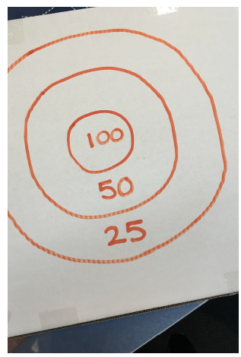
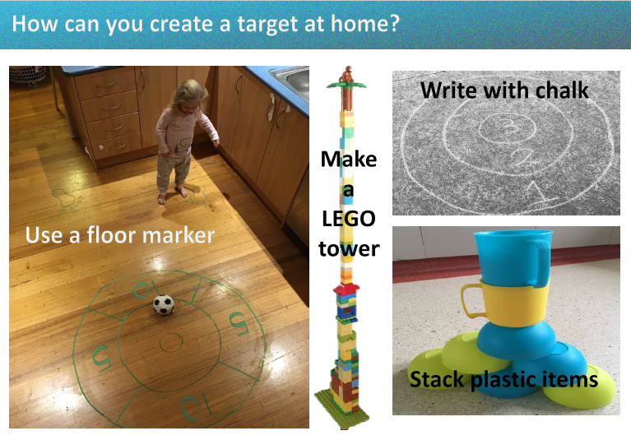
Texta + Cardboard = Targert -----------------------------------------------
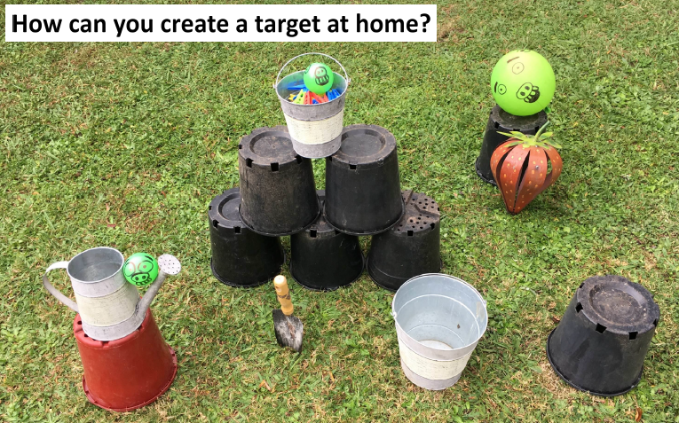

Soccer Skills at home:
https://www.youtube.com/watch?v=SoijY4BUCtw – Beginner skill

Keep the Balloon Up
Outdoor on a calm, windless day, or inside, have your kids use their hands or half of a pool noodle to keep a balloon afloat. How long can they keep the balloon off the ground?
Skills developed: volleying, striking

Obstacle Course
Indoors or out, let your imagination run wild as you set up an obstacle course for your child. Have them crawl under tables, climb over chairs, jump over ropes, hop from cone to cone, crawl through a cardboard box, jump through a line of hula hoops, throw a family of stuffed animals into a laundry basket, etc. etc.
Skills developed: agility, balance, coordination

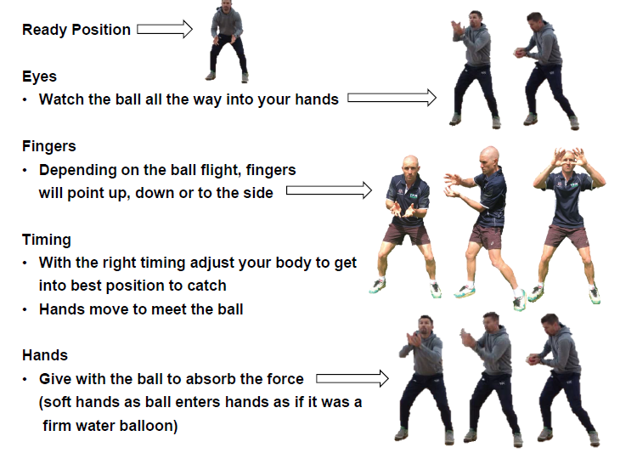
How To Catch ->

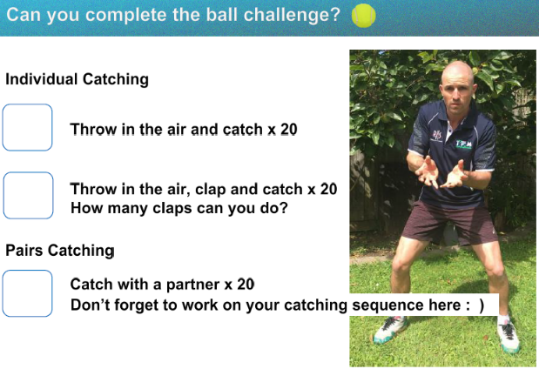

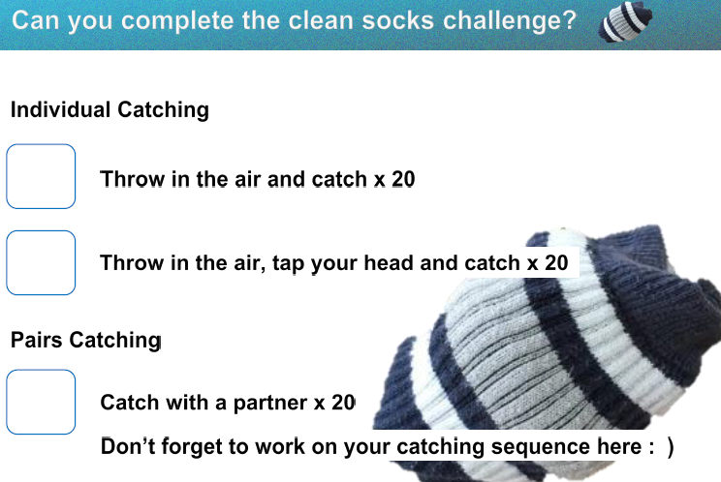

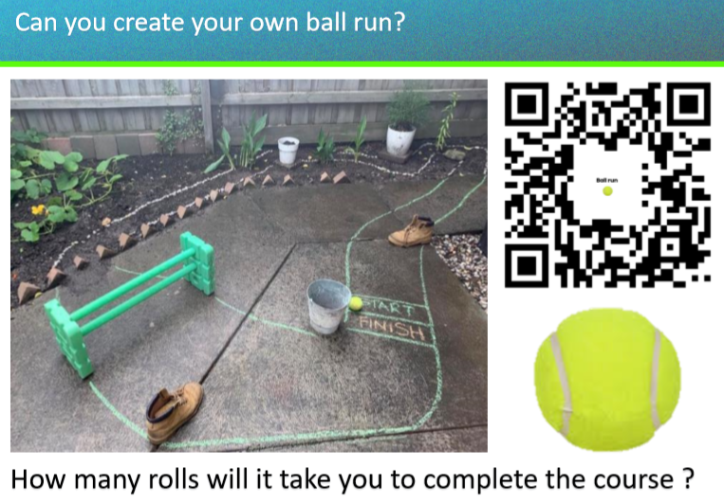

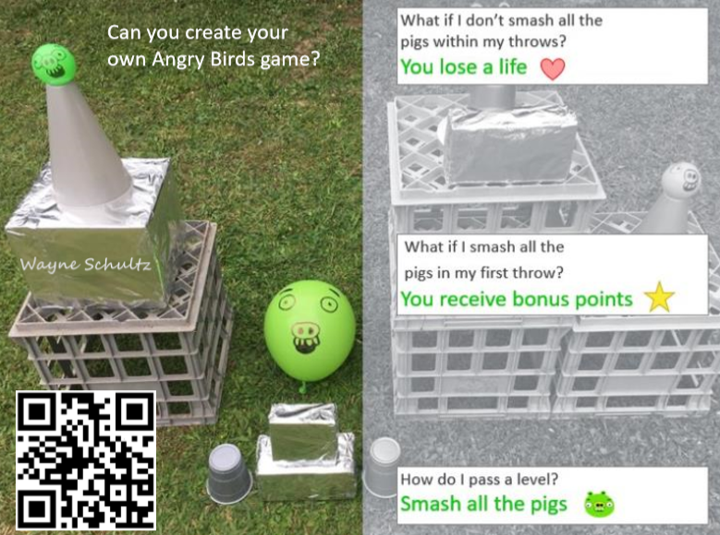

Traditional Indigenous Games – Over 120 different games
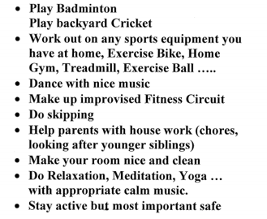
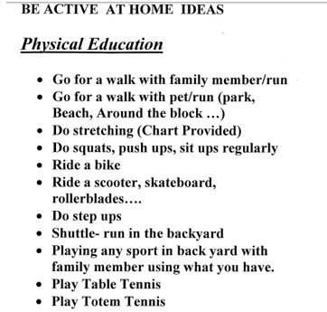
https://www.sportaus.gov.au/yulunga

Workout – Do every activity once, 2 minute break and then repeat for however many times it says for your grade to do it.
Grade 1 - 3 times Grade 2 - 4 times Grade 3 - 5 times Grade 4 - 6 times Grade 5 - 7 times Grade 6 – 7 times
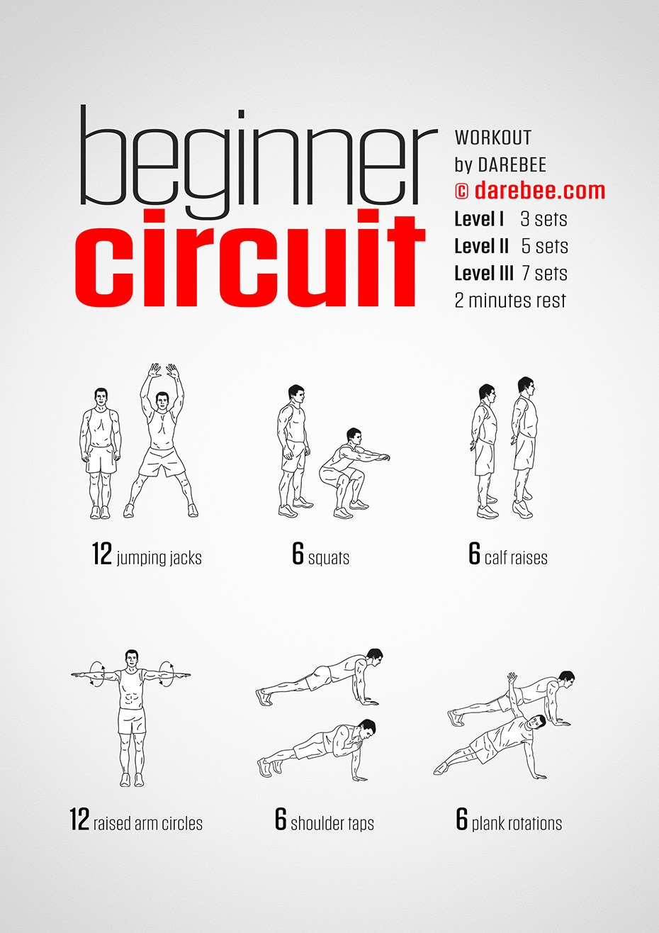

FMS Skills Challenge
Try the challenges below and tick the I can statements when you achieve them:
Overarm Throw  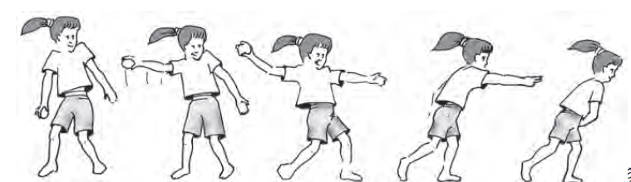  - I can throw to a target 5 steps away  - I can throw to a target 10 steps away  - I can throw to a big target 5 times in a row  - I can throw to a small target on a wall  - I can throw to a small target on a wall 5 times in a row | Catch  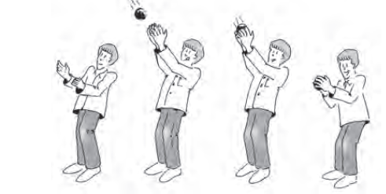  - I can throw a ball up in the air and catch it 5 times  - I can throw a ball at a wall and catch it with 2 hands  - I can throw a ball at a wall and catch it with 1 hand  - I can catch a high ball above my head  - I can jump and catch a ball in the air
Kick  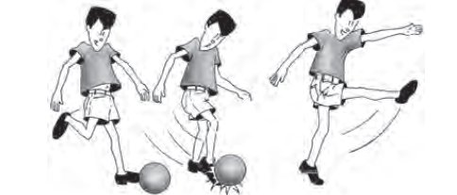  - I can kick a ball into a big goal  - I can kick a ball into a small goal  - I can kick a ball into a small goal 5 times in a row  - I can kick a ball into a goal with a run up  - I can kick a ball around an obstacle into a goal (bend the ball around a defender!) | Bounce  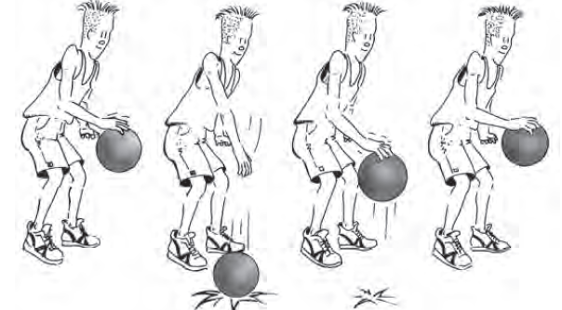  - I can bounce a ball 10 times in a row with my fingertips  - I can bounce a ball 10 times in a row without looking at the ball  - I can bounce a ball 10 times in a row alternating hands (left-right-left…)  - I can bounce a ball at below knee height to hip height  - I can bounce a ball through my legs

PHYSICAL ACTIVITY AROUND THE HOUSE!
Work through the list of activities below and tick each off as you complete them –
If they are too easy, make them harder
The older you are the harder they should be!
- Walk/run 50 or 100 steps
- Throw a ball at a wall and catch it 20 times (use a ball or scrunched up newspaper)
- Keep a balloon or scrunched up paper ball in the air for 10 hits in a row
- Animal walks – walk into all rooms of your house using your favourite animal walk (eg” bear crawl, kangaroo jump, or inch worm)
- 20 star jumps
- Run on the spot for one minute
- Throw and catch a scarf into the air 30 times – try using different hands
- Make 100 skips
- Create a hopscotch pattern with chalk, tape, socks or ribbons and complete it
- Stand on one foot and throw a ball, soft toy or scrunched up paper ball from one hand to the other
- Play your favourite song and dance
- Make a balance beam/tightrope with a rope, plank or draw a chalk line on the ground and walk on it
- Make an obstacle course with things in your home – you have to go over, under and around!
- Practice your long jump – mark a line on the ground to start behind and then jump as far forward as you can. Try 10 jumps and see if you can beat your last jump
- Set up a goal and try to get 20 kicks in
- Set up some toys or bottles as targets and roll a ball to knock them over. If you knock a target over, step back to make it more challenging
- Make a target on an outdoor wall to throw at with chalk, paper, tape or using bricks. Try to hit the targets 10 times. Move further back to make it more challenging
- Use a hula hoop and try to keep it up as long as possible!
- Read a story book with an often repeated word – if the word is mentioned in the story, you need to do an activity (eg: 5 star jumps)
Think of your own and list them below:
- _________________________________________________________________________________
- _________________________________________________________________________________
- _________________________________________________________________________________

