THURSDAY Week 2 30/7/2020
Before you do anything else make sure to follow the following instructions!!!!!!
- Go to File
- Click Save as
- Add your name to the name of this document (e.g. Week 1 Friday – Freddie)
- Complete your work (always hit Save!!!!)

When you’ve finished share with your teacher by either:
  - Sending it in an email, or
(See video on how to email here)
  - SHARE the document with them from word(much better than email!!!!)
See video here on sharing your work from your OneDrive

((((P.S. if you accidentally delete something, just press “Ctrl z”))))))
Session 1: Reading
9.15- 10.00- Reading

Reading Eggspress (yes, the WHOLE 45 minutes)

Session 2: Maths

Multiplication: Using Arrays to explore Factors
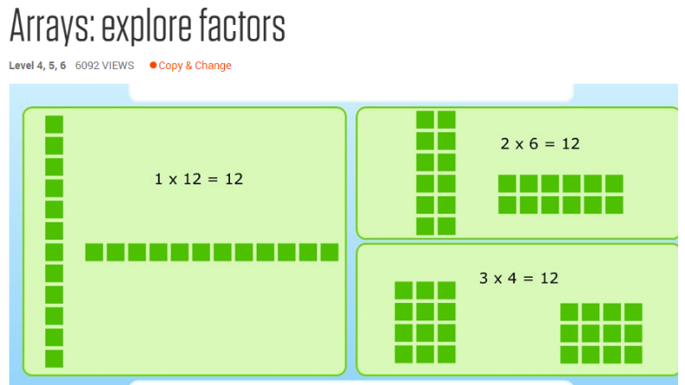
Explore how numbers can be broken up with factors. Predict the factors of a number in the range 1 to 50. Make an array of equal rows and columns with the number to check its factors. Choose a statement to describe how many factors the number has.

Click the link to take you to an interactive game.
http://fuse.education.vic.gov.au/Resource/ByPin?Pin=2YEXHM&SearchScope=All
Click VIEW in the left hand corner of the game to play

Session 3: Arts
Click HERE for week 2 Arts Lesson from Mrs Karaca. Don’t forget to send her your completed work through email or Flexibuzz.

Session 4: Mindfulness colouring
Read the following story and answer the questions below.

Patrick has lived with his Dad for the past six years since his parents were divorced. He likes living with his Dad because they get to spend lots of time together doing fun things. Lately things have started to change a little because Patrick’s Dad has got a new girlfriend and they seemed to be getting serious. She has an 8-year-old daughter and 6 year old son and Patrick’s Dad is always inviting them along to their place for dinner and BBQs and when they go out to the movies and stuff. Patrick feels like he is being left out.

- Do you think feeling left out is stressful for Patrick?
- Who could Patrick talk to about his feelings?
- What could Patrick say to Dad?
- Have you ever had something worrying you that was hard to tell your parents about? Tell us about it.

Session 5: P.E.
Grade 3-6 Fitness Circuit/Choice Board Instructions
Each week students will be given a choice board of activities. The centre activities MUST be done with proof of it being done with the fitness circuit checklist. The rest of the activities on the sheet are student's choice. It is required you are doing these for at least 30 minutes a day.

The video - “Fitness Circuit Explanation” will explain how to do it
The video “Fitness Circuit Activities” shows you all the activities and explains how to do them, you are picking 2 activities from each section.
The “Fitness Circuit Checklist” on your MONDAY pack is where you write down the activities you pick. The colours match to the cards.
The following YouTube link will show you exactly how to do each activity. Just look for the name of the activity and it will show you exactly how to do it
https://www.youtube.com/playlist?list=PL2hDszH4XLgW5v_wEa2onDEThj7TuusxQ
Complete your chosen 12 fitness activities twice a week, this is your main P.E task for the week and MUST be completed and recorded.
You are doing each activity for a minute at a time, making sure you have a minute break in between.

When you are not doing your Fitness Circuit, you are to do your CHOICE BOARD which is at the bottom of your MONDAY activities pack.

At the end of the week, send your work to me either on flexibuzz or email. Send a few photos of you doing your activities!
My email: Andreas.Jordanidis@education.vic.gov.au

Carry all the groceries in for your parents, one piece at a time. | Create an obstacle course at home. Challenge your family to do it. | Who in your family can do the most push ups? | Create some dance moves to your favourite song
Research a yoga video for kids on YouTube.  Have a go at doing it! | See who in your family can plank for the longest | Use an empty bottle as your target, place it anywhere in your house and try to hit it with a pair of socks. Try some trick shots! | How long can you keep your arms stretched above your head?
Alphabet challenge  30 seconds per letter  Try and find an item with every letter of the alphabet. | FOCUS ON FITNESS  Complete your fitness circuit twice this week.  Did you change your activities or keep the same?  Why/Why not? |  | Balance on one leg for as long as you can.  Challenge your family to beat it
Lily Pads  Put cushions and pillows on the floor, jump from one to another | Make a small goal – aim to kick a ball into the goal 20 times in a row. | Animal Charades  Challenge a sibling or parent to work out what animal you are being, they do the same and you guess! | Play follow the leader with a sibling or parent
Kick a soccer ball against the wall or pass to a family member | Go for a bike ride/walk your dog | Take your dirty clothes out into the laundry one piece of clothing at a time | See how long you can walk with a book on your head.
PE CHOICE BOARD

