Wednesday Week 7

9.15- 10.00 am – Literacy- Both spelling and chapter Book.
Reading – Reading Eggspress
Chapter Books and Comprehension Activity
https://readingeggs.com.au/
Complete assigned tasks

9.15- 10.00 am - Literacy
Reading Eggspress – Spelling
https://readingeggs.com.au/
Log into readingeggspress to find your assigned lesson
Yellow- Lesson- 118-
Prefixes un, dis, mis
Orange- Lesson –159
Prefixes un, dis, mis.

10:00 – 10:30 am – Numeracy – Complete week 7 PODS
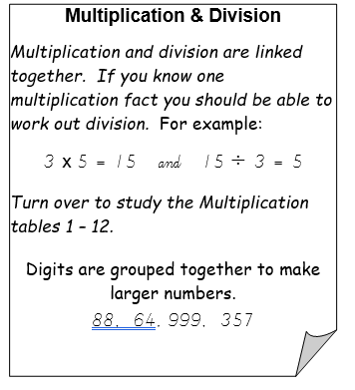

www.studyladder.com.au

Students to work independently for
45 mins on assigned study ladder tasks.
Begin with Rapid Recall Activities for 10 mins
Then move on to Multiplication tasks

11:30 – 12:30 –ART with Mrs Karaca

Click HERE for this week’s lesson.

Mrs Karaca will be on Webex meetings today from 2pm to answer any questions about this weeks lesson.

12.20 to 1:20pm SHARE

SHARE
Choices
Today we are learning to;
- Think before acting in a way that may affect or upset others.
- Building skills to establish and maintain relationships with others.
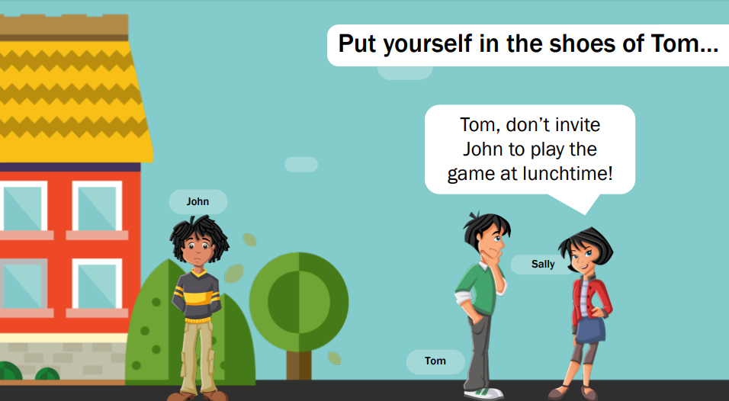

- What do you think is Tom thinking?

- How do you think John is feeling?

- What might prevent Tom from making a good decision in this situation?

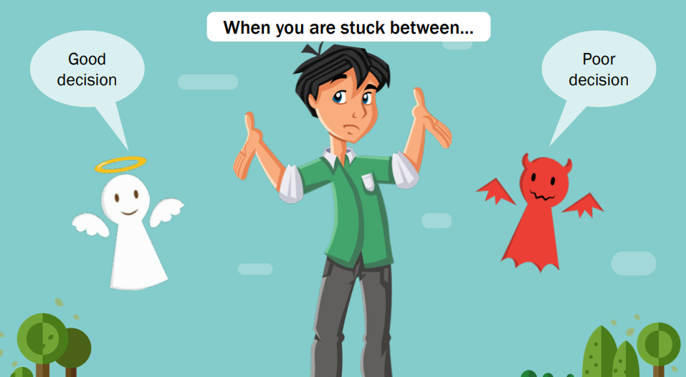

Some factors that may prevent you making a good decision when interacting with friends are:
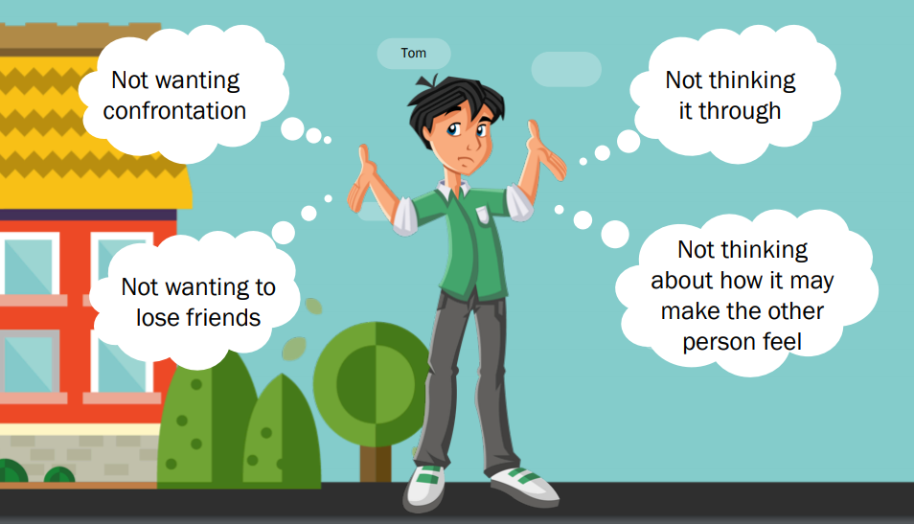
Remember that your choice can:
• Not only affect you, it can affect others e.g. your family, friends and the school.
• Change how other people think of you.
• Be a poor decision but it is important to learn from your mistakes. An apology can be very helpful
when you have done the wrong thing.

- Can you create your own ‘put yourself in ….. shoes’ situation?

If you don’t know who to talk to about something you’ve experienced, you can call or start a web
chat with a counsellor at Kids Helpline.
You don’t have to be sad to call them — and you can call them anytime of the day or night.
Visit: https://www.kidshelpline.com.au
Phone: 1800 55 1800
There are also many resources and tips for children online at:
https://www.esafety.gov.au/kids

2:30 – 3:30 PE (Sport)
Grade 3-6 Term 3 Dance Unit Instructions
For the last 4 weeks of term, the grade 3 to 6 students will be completing some dance routines. Dance is a great way to improve your timing, as well as endurance, flexibility and maintaining fitness overall. You will be continuing the choice boards as well – 30 minutes a day!

Each week you will have 2 videos you need to watch and complete. The first one being a warmup video (with stretches etc), the other being a dance routine video.
You will also be asked to complete a reflection sheet and your usual choice board each week and send it to me. These will be found on your MONDAY homework. 1 day you do your dance, the other 4 days you are doing your choice board.

To complete each weeks work you must do the follow.
1) Take at least 1 photo or video of you attempting the dance routine
2) Fill in and complete the reflection sheet.
3) Fill in your choice board with what activities you did.
When those 3 are done you need to send the work to me either over Xuno, Email or for Grade 5/6 over Microsoft Teams.
Email: Andreas.Jordanidis@education.vic.gov.au

