Friday
Week 4
9.15- 10.00 am –Literacy- Smart Ice-cream-

Click HERE to open your writing session

10:00 – 10:30 am – Numeracy- Division
https://www.topmarks.co.uk/maths-games/7-11-years/multiplication-and-division
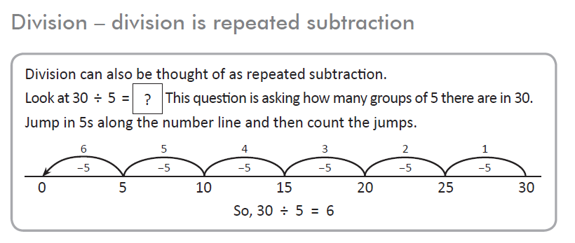

Add text boxes or Copy the equations in your scrapbook
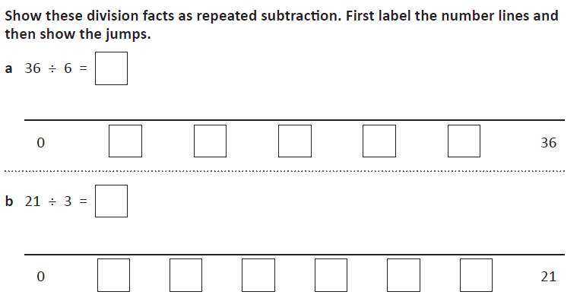

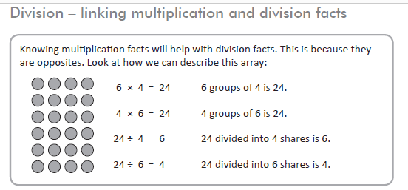

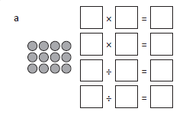

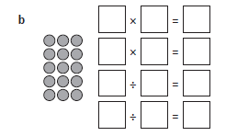
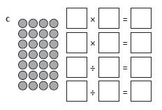

11:30 – 12:30 – INQUIRY
Global Warming

Using the Inquiry Note Planner from Wednesday’s Inquiry session complete your own independent research into the question:
What can we do to stop Global warming?

Consider what you can do as an individual, as a school, as a country and as the world. Write your answers in the my research column in your inquiry planner.

Some possible search terms for google include: global warming for kids, what can we do to stop global warming, facts about global warming.

Don’t forget to write down the name of the website where you get your information from.

12:30 to 1:20pm

Finish Off Activities – Time to
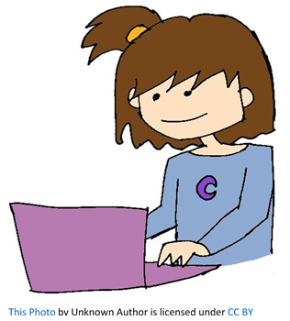
complete your set work for the week.

2:30 – 3:30 PE (Sport)
Grade 3-6 Fitness Circuit/Choice Board Instructions
Each week students will be given a choice board of activities. The centre activities MUST be done with proof of it being done with the fitness circuit checklist. The rest of the activities on the sheet are student's choice. It is required you are doing these for at least 30 minutes a day.

The video - “Fitness Circuit Explanation” will explain how to do it
The video “Fitness Circuit Activities” shows you all the activities and explains how to do them, you are picking 2 activities from each section.
The “Fitness Circuit Checklist” on your MONDAY pack is where you write down the activities you pick. The colours match to the cards.
The following YouTube link will show you exactly how to do each activity. Just look for the name of the activity and it will show you exactly how to do it
https://www.youtube.com/playlist?list=PL2hDszH4XLgW5v_wEa2onDEThj7TuusxQ
Complete your chosen 12 fitness activities twice a week, this is your main P.E task for the week and MUST be completed and recorded.
You are doing each activity for a minute at a time, making sure you have a minute break in between.

When you are not doing your Fitness Circuit, you are to do your CHOICE BOARD which is at the bottom of your MONDAY activities pack.

At the end of the week, send your work to me either on XUNO app or email. Send a few photos of you doing your activities!
My email: Andreas.Jordanidis@education.vic.gov.au

