Tuesday
Week 3
9.15- 10.00 am – Literacy
Smart Ice-cream

Click here to open your writing session

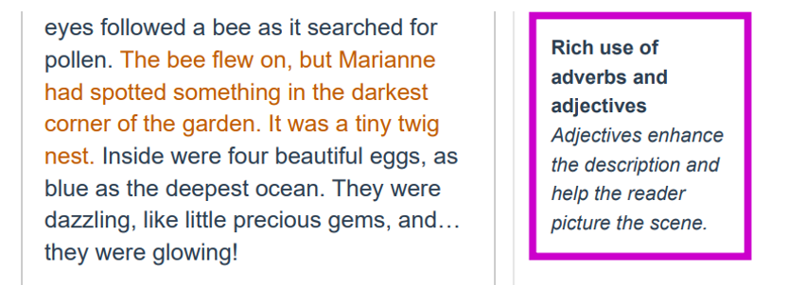

https://www.youtube.com/watch?v=yJ-T8z2-Zg4
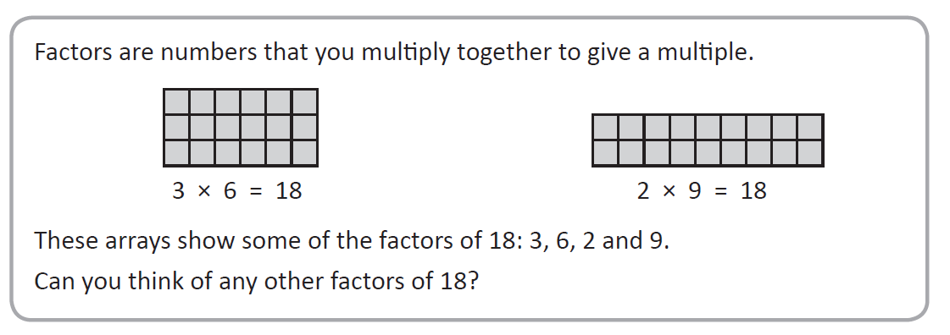
10:00 – 10:30 am – Factors and Multiples
Complete the number sentence for each set of arrays and then list the factors.

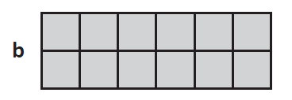
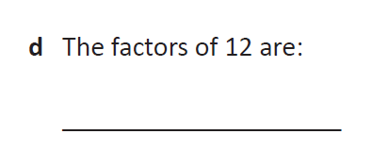
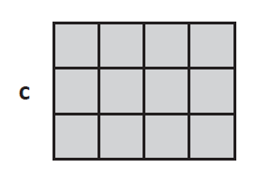
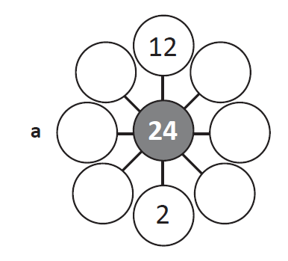
Complete each diagram to show the factors of the number in the middle circle:
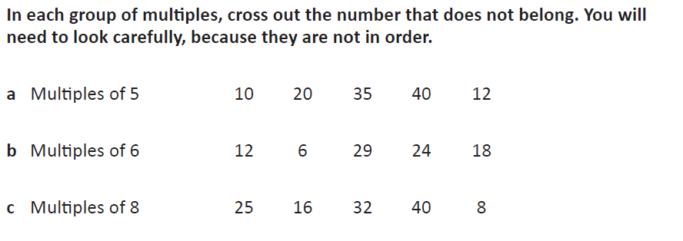

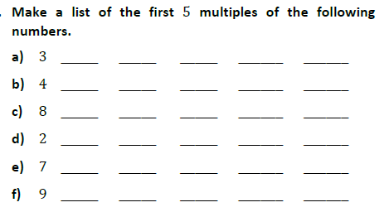

12:30 – 1:20 – Inquiry
Central Idea
The potential for tomorrow depends on what we do today.

Watch the clip below of the story The Lorax by Dr Seuss

https://www.youtube.com/watch?v=sJ0BvL5ELko

The book contains the famous line “Unless someone like you cares a whole awful lot. Nothing is going to get better, its not.”

What does this statement have to do with our inquiry topic?

One of the central themes in this book is Want vs Need.
List 5 things that you would consider to be wants.
List 5 things that you would consider to be needs.
__________________________________________________________________

Write your Inquiry response here……

12:30 to 1:20pm Mindfulness- session 1

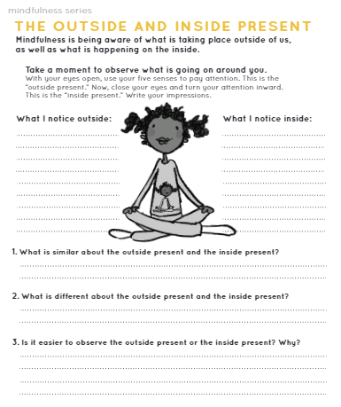

2:30 – 3:30 PE (Sport)
Grade 3-6 Fitness Circuit/Choice Board Instructions
Each week students will be given a choice board of activities. The centre activities MUST be done with proof of it being done with the fitness circuit checklist. The rest of the activities on the sheet are student's choice. It is required you are doing these for at least 30 minutes a day.

The video - “Fitness Circuit Explanation” will explain how to do it
The video “Fitness Circuit Activities” shows you all the activities and explains how to do them, you are picking 2 activities from each section.
The “Fitness Circuit Checklist” on your MONDAY pack is where you write down the activities you pick. The colours match to the cards.
The following YouTube link will show you exactly how to do each activity. Just look for the name of the activity and it will show you exactly how to do it
https://www.youtube.com/playlist?list=PL2hDszH4XLgW5v_wEa2onDEThj7TuusxQ
Complete your chosen 12 fitness activities twice a week, this is your main P.E task for the week and MUST be completed and recorded.
You are doing each activity for a minute at a time, making sure you have a minute break in between.

When you are not doing your Fitness Circuit, you are to do your CHOICE BOARD which is at the bottom of your MONDAY activities pack.

At the end of the week, send your work to me either on flexibuzz or email. Send a few photos of you doing your activities!
My email: Andreas.Jordanidis@education.vic.gov.au

