Thursday
Week 3
9.15- 10.00 am – Literacy
Reading – Reading Eggspress
Chapter Books and Comprehension Activity.
https://readingeggs.com.au/
Complete assigned tasks

10:00 – 10:30 am – Numeracy- Multiplication Split strategy

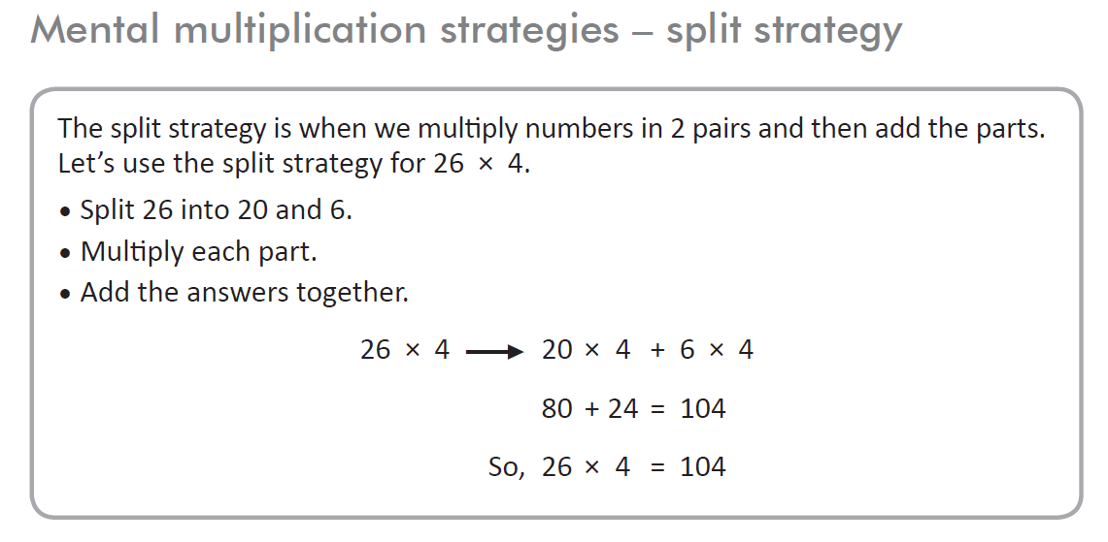
https://www.topmarks.co.uk/maths-games/7-11-years/multiplication-and-division

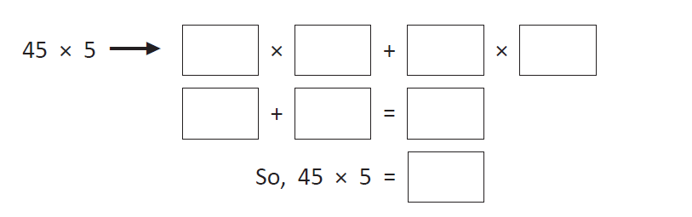
Answer these problems:
a Jack runs 25 km per week. How far does he run over 6 weeks?
b Jim earns $22 pocket money per week. If he saves half of this, how much will he have saved at the end of 8 weeks?
c What number am I? I am in the 3 times table, 4 times table and 6 times table.
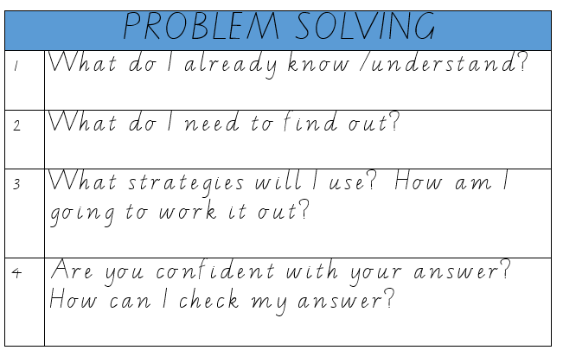
I’m not 12.
I am

Record your answers either in a word document, on paper or in your maths book.
11:30 – 12:30 Arts with Mrs Karaca
CLICK HERE FOR WEEK 3 LESSON

12:30 to 1:20pm Mindfulness

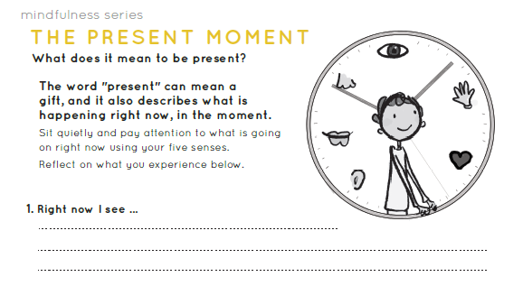

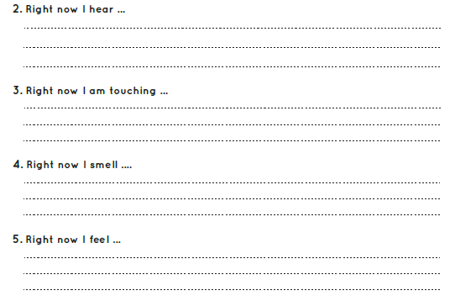

The Present Moment.
What is the difference between the past, the present, and the future? Below write or draw something
that took place in the past, something that might take place in the future and something that is happening
right now.
PAST:

PRESENT:

FUTURE:

2:30 – 3:30 PE (Sport)
Grade 3-6 Fitness Circuit/Choice Board Instructions
Each week students will be given a choice board of activities. The centre activities MUST be done with proof of it being done with the fitness circuit checklist. The rest of the activities on the sheet are student's choice. It is required you are doing these for at least 30 minutes a day.

The video - “Fitness Circuit Explanation” will explain how to do it
The video “Fitness Circuit Activities” shows you all the activities and explains how to do them, you are picking 2 activities from each section.
The “Fitness Circuit Checklist” on your MONDAY pack is where you write down the activities you pick. The colours match to the cards.
The following YouTube link will show you exactly how to do each activity. Just look for the name of the activity and it will show you exactly how to do it
https://www.youtube.com/playlist?list=PL2hDszH4XLgW5v_wEa2onDEThj7TuusxQ
Complete your chosen 12 fitness activities twice a week, this is your main P.E task for the week and MUST be completed and recorded.
You are doing each activity for a minute at a time, making sure you have a minute break in between.

When you are not doing your Fitness Circuit, you are to do your CHOICE BOARD which is at the bottom of your MONDAY activities pack.

At the end of the week, send your work to me either on flexibuzz or email. Send a few photos of you doing your activities!
My email: Andreas.Jordanidis@education.vic.gov.au

