9.15- 10.00 am - Literacy
Reading Eggspress – Spelling
https://readingeggs.com.au/
Log into readingeggspress to find your assigned lesson

Yellow- Lesson -142
Suffix ly.

Orange- Lesson -176
Suffix ly.
Monday
Week 3

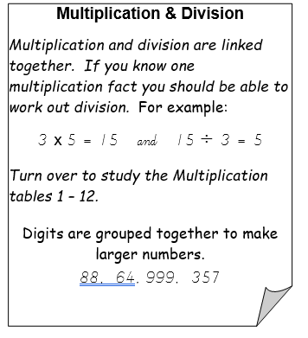
www.studyladder.com.au
Students to work independently for
45 mins on assigned study ladder tasks.
Begin with Rapid Recall Activities for
10 mins.
Then move on to Multiplication tasks.

10:00 – 10:30 am – Numeracy-

LOTE
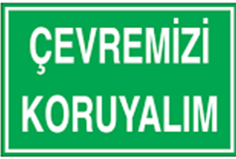

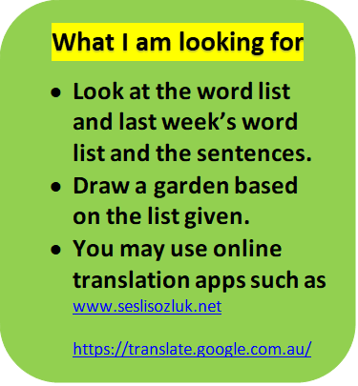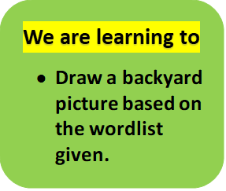

ARKA BAHÇEM – MY BACKYARD
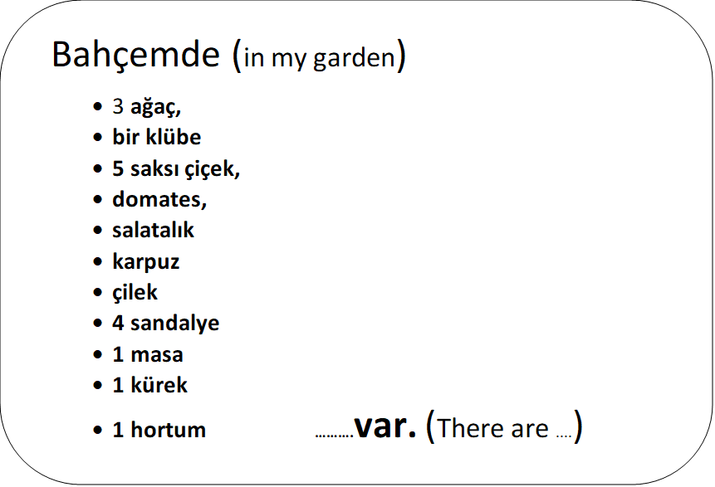

12:30 – 1:20 – Share- session 1

Share- session 1 Ask students what they think the word RESPECT means.
Ask students to draw a Y chart in their books or just the words below and describe what a respectful relationship looks like, sounds like and feels like between each of the arms of the Y. What a respectful relationship looks like, sounds like and feels like.
Brainstorm a list of qualities that are important in positive relationship. Prioritise the list of qualities and come to a decision about which seven are the most important for positive and respectful relationships. Now make your lists of 7 for each section.
Looks Like

Sounds Like

Feels Like

Write what would happen to the relationship if one or more of the qualities they identified were not present in that relationship. Discuss the impact on the relationship and how the dynamics and nature of the relationship.

2.30- 3.00 P.E.
3.00– 3:20. Assembly
Grade 3-6 Fitness Circuit/Choice Board Instructions
Each week students will be given a choice board of activities. The centre activities MUST be done with proof of it being done with the fitness circuit checklist. The rest of the activities on the sheet are student's choice. It is required you are doing these for at least 30 minutes a day.

The video - “Fitness Circuit Explanation” will explain how to do it
The video “Fitness Circuit Activities” shows you all the activities and explains how to do them, you are picking 2 activities from each section.
The “Fitness Circuit Checklist” on your MONDAY pack is where you write down the activities you pick. The colours match to the cards.
The following YouTube link will show you exactly how to do each activity. Just look for the name of the activity and it will show you exactly how to do it
https://www.youtube.com/playlist?list=PL2hDszH4XLgW5v_wEa2onDEThj7TuusxQ
Complete your chosen 12 fitness activities twice a week, this is your main P.E task for the week and MUST be completed and recorded.
You are doing each activity for a minute at a time, making sure you have a minute break in between.

When you are not doing your Fitness Circuit, you are to do your CHOICE BOARD which is at the bottom of your MONDAY activities pack.

At the end of the week, send your work to me either on flexibuzz or email. Send a few photos of you doing your activities!
My email: Andreas.Jordanidis@education.vic.gov.au
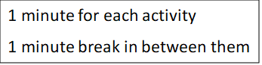
Fitness Circuit Checklist: Week 3
Name:  Room: | Attempt 1 | Attempt 2
Whole Body Strength

Core Strength

Arm Strength

Leg Strength

Stamina

Flexibility & Balance

Whole Body

Core Strength

Arm Strength

Leg Strength

Stamina

Flexibility & Balance

How many times in a row can you juggle a soccer ball? | Play tiggy with your family | Set up a goal and shoot it in 15 times | Hang out the washing for your family.
How many items can you stack on your head without falling over? | Who can do the most push ups? | Play a game of closest to pin. See who can throw a pair of socks closest to an empty bottle without knocking it over | How long can you keep your arms stretched above your head?
Scavenger Hunt  Find: Blue bottle, yellow flower, Green clothes, Purple socks, something beginning with k, d, f, a, j, w | FOCUS ON FITNESS  Complete your fitness circuit twice this week.  Did you change your activities or keep the same?  Why/Why not? |  | Long Jump,  See who in your family can jump the furthers from just where they stand.
Practice Basketball shooting (if you have a ring)  If not – Find a spot high against a wall and hit it each time with a ball | Throw a ball against the wall and catch it 20 times in a row.  Challenge yourself to do it one handed | Think about animals that you might see in the zoo.  How man of them can you move like? | Meditate for 5 minutes, clothes your eyes, lay down, try and clear your mind. Relaxing music will help.
How long can you do a wall sit for?  Challenge your family to it! | Do 4 different Just Dance Videos on YouTube  Ask your family to join in | Create the letters of your name using only your body.  Use your family to help you make it. | See how long you can walk with a book on your head.

