**Tuesday**

**Week One**

|  |
| --- |
| 9.15- 10.00 am – Literacy  Writing Legends |
| Complete a quick write in the space provide below using the prompt The lost eggs of Ostrenon |



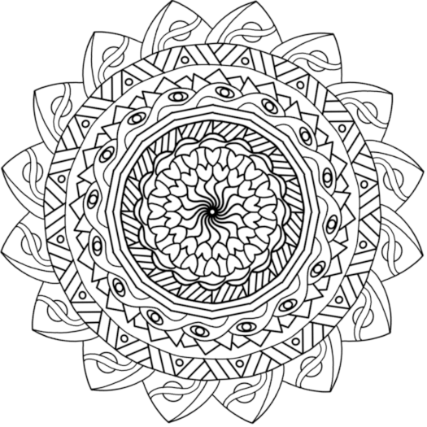

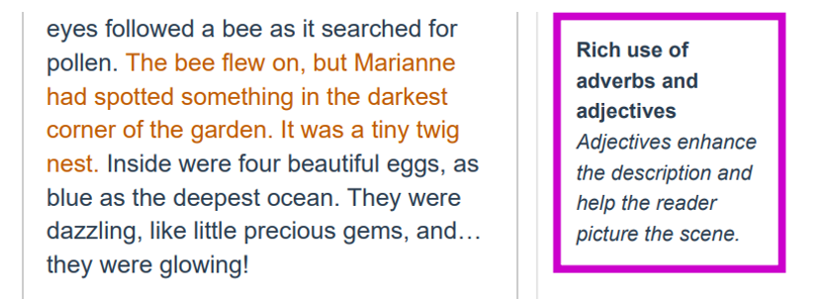

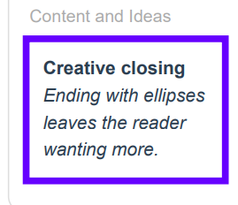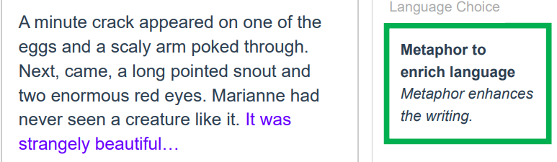

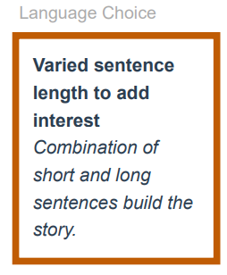

**Write your story here…**

|  |
| --- |
| Tuesday Maths  Times Table Shift  Let’s see how well we can identify patterns in our timetables.  Click on the link below and start at level 1 and work your way all the way through to level 4.  <https://nrich.maths.org/6863>  Reflection  What did you notice when doing this activity?  How will this help you doing multiplication?  Record your answers either in a word document, on paper or in your maths book. |

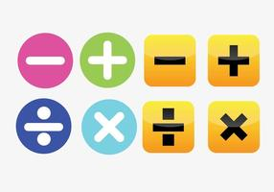

[This Photo](https://www.vecteezy.com/backgrounds-wallpaper/42382-math-problems) by Unknown Author is licensed under [CC BY-NC-ND](https://creativecommons.org/licenses/by-nc-nd/3.0/)

10:00 – 10:30 am – Numeracy

<https://www.topmarks.co.uk/maths-games/7-11-years/multiplication-and-division>

|  |
| --- |
| 12:30 – 1:20 – Inquiry  **Central Idea**  The potential for tomorrow depends on what we do today.  **What environmental problem can you identify from looking at this picture?**  **What do you think has caused this to happen?** |

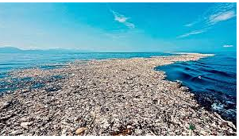

Write your Inquiry response here……

|  |
| --- |
| 12:30 to 1:20pm Mindfulness- session 1 |

Watch this clip and have a try of each exercise. Remember to use these tips if you start to feel worried.

5 Tools And Breathing Exercises For Kids Anxiety During COVID-19

<https://www.youtube.com/watch?v=-QMycnTXwN0>

You can color the mandala to calm down when you need to.



|  |
| --- |
| 2:30 – 3:30 PE (Sport) |
| **Grade 3-6 Fitness Circuit/Choice Board Instructions**  Each week students will be given a choice board of activities. The centre activities **MUST** be done with proof of it being done with the fitness circuit checklist. The rest of the activities on the sheet are student's choice. It is required you are doing these for **at least 30 minutes a day.**    Watch the video [**“Fitness Circuit Explanation”**](https://vimeo.com/438788238). This will explain everything for P.E.  Click Here [**“Fitness Circuit Activities”**](https://www.meadowheightsps.vic.edu.au/uploaded_files/media/website__fitness_circuit_activities.docx) so you can look at the activities at your own pace. You are picking 2 activities from each section  On the document below that has **“Fitness Circuit Checklist”**at the top, you are going to write on the left-hand column the activities you will do.  The following YouTube link will show you exactly how to do each activity. Just look for the name of the activity and it will show you exactly how to do it  <https://www.youtube.com/playlist?list=PL2hDszH4XLgW5v_wEa2onDEThj7TuusxQ>  Complete your chosen 12 fitness activities twice a week, This is your main P.E task for the week and **MUST** be completed and recorded.  You are doing each activity for **a minute**at a time, making sure you have **a minute break** in between.  Every other day you are not doing those activities you have the choice of doing activities from the choice board for at least 30 minutes.    Send through your **COMPLETED** Fitness Circuit checklist, photo proof of you doing the workouts and proof of you doing the choice board. Either on the P.E/Sport Flexibuzz or my email – [Andreas.Jordanidis@education.vic.gov.au](mailto:Andreas.Jordanidis@education.vic.gov.au)  I look forward to seeing all your workouts! |

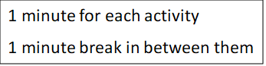 Fitness Circuit Checklist: Week 1

|  |  |  |
| --- | --- | --- |
| **Name:**  **Room:** | **Attempt 1** | **Attempt 2** |
| **Whole Body Strength** |  |  |
| **Core Strength** |  |  |
| **Arm Strength** |  |  |
| **Leg Strength** |  |  |
| **Stamina** |  |  |
| **Flexibility & Balance** |  |  |
| **Whole Body** |  |  |
| **Core Strength** |  |  |
| **Arm Strength** |  |  |
| **Leg Strength** |  |  |
| **Stamina** |  |  |
| **Flexibility & Balance** |  |  |

|  |  |  |  |
| --- | --- | --- | --- |
| Keep a balloon or scrunched up paper in the air for 10 hits in a row. See what your record could be. | Create an obstacle course at home, see how quickly you can do it. | Time yourself how long it takes to clean your room completely. | Throw a ball and catch it against the wall 20 times |
| Research a yoga video for kids on YouTube.    Have a go at doing it! | Crab walk up and down your hallway 5 times.  If no hallway, from your bedroom to the kitchen. | Put a towel on the floor, throw a pair of socks from as many different spots as you can. Try some trick shots! | Put all the dishes away for your family |
| Name Challenge  Find and collect items in your house that start with each letter of your name. 30 seconds per letter! | **FOCUS ON FITNESS**  **Complete your fitness circuit twice this week.**  **Did you get better the second time you did it?**  **Remember to record your results!** | | Balance on one leg for as long as you can.  Challenge your family to beat it |
| Ball Bounce  How many times can you bounce a ball in a minute?  Challenge your family to beat it | Make a goal outside, kick a ball into the goal from as many different spots in your backyard as possible | Throw and catch  Throw a ball or pair of socks up in the air, as high as you can and catch it  See how many claps you can do before you catch it | Bottle bowling    Play a game of bowling with some bottles. |
| Kick a soccer ball against the wall or pass to a family member | Go for a bike ride/walk your dog | Dance to your favourite song, whenever there is no singing you must freeze like a statue until there is singing again | Clean the backyard |