Wednesday
Week 8

9.15- 10.00 am – Literacy- Both spelling and chapter Book.
Reading – Reading Eggspress
Chapter Books and Comprehension Activity
https://readingeggs.com.au/
Complete assigned tasks

9.15- 10.00 am - Literacy
Reading Eggspress – Spelling
https://readingeggs.com.au/
Log into readingeggspress to find your assigned lesson
Yellow- Lesson- 119
Plurals s and ies.
Orange- Lesson –164
Plurals s and ies.

10:00 – 11.00 am – Numeracy –Kahoots Game.
https://kahoot.it/

Students will login into Kahoots and play- Ms Starr Meeting Number.

11:30 – 12:30 –ART
Mrs Karaca will be on Webex today from 2pm to help you with todays lesson.

Click Here to see this weeks lesson

12.20 to 1:20pm SHARE

Essential Question
How do you chat safely with people you meet online?
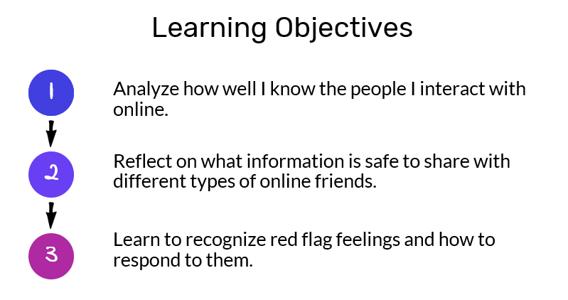

Directions
Think about whom you interact with online and using devices and apps, and write them into the table.
Person  Write their name or a description. | Background  Explain how you know the person. | How You Interact  Describe the devices, apps,  or websites.
Example: my best friend | I've known her since third grade, when we started on the same track team. | We text with each other all the time and FaceTime sometimes.
Example: smoshfan35 | We both comment on Smosh videos. | Mostly we message through YouTube comments. Sometimes we chat on Messenger.

Please complete.
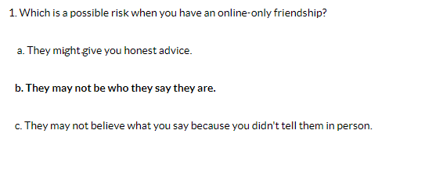
2:30 – 3:30 PE (Sport)
Grade 3-6 Term 3 Dance Unit Instructions
For the last 4 weeks of term, the grade 3 to 6 students will be completing some dance routines. Dance is a great way to improve your timing, as well as endurance, flexibility and maintaining fitness overall. You will be continuing the choice boards as well – 30 minutes a day!

Each week you will have 2 videos you need to watch and complete. The first one being a warmup video (with stretches etc), the other being a dance routine video.
You will also be asked to complete a reflection sheet and your usual choice board each week and send it to me. These will be found on your MONDAY homework.

To complete each weeks work you must do the follow.
1) Take at least 1 photo or video of you attempting the dance routine
2) Fill in and complete the reflection sheet.
3) Fill in your choice board with what activities you did.
When those 3 are done you need to send the work to me either over Xuno, Email or for Grade 5/6 over Microsoft Teams.
Email: Andreas.Jordanidis@education.vic.gov.au
Each week, you will have a web ex time you can meet with me to ask me questions.
5/6s: I will be on WebEx meetings if you need me to answer any questions from 2-3 pm on a Tuesday
My meeting number can be found on Xuno, in the newsletter section.

