Tuesday
Week 5
9.15- 10.00 am – Literacy – Writing Legends

https://www.writinglegends.com/
Select any 2 quick writes from writing legends as your task today, free choice.

Students are to select 2 quick writes form Writing Legends of your own choice for this session. Complete the writing task on writing legends and your teacher will give you feedback.
10:00 – 10:30 am – Maths
Pre-test: Fractions on Forms

Click here to complete the Fractions Pre Test
https://forms.office.com/Pages/ResponsePage.aspx?id=N7Ns2Ycaz0S2mzzsM0pMH5K9FlN34NhLqfeLREwsrXlUNUZBTFpLSU4xRzg5SjJVR0ZDMEw2VzNRVC4u

Remember this a Pre-Test so the more questions you try to answer means
We have more information on what you need help with.
Try and answer as many questions as possible.

You must be signed into office 365 before opening the test.
11:30 – 12:30 Inquiry Deforestation

Using the Inquiry Note Planner from Week 4’s Inquiry session complete your own independent research into the question:
What are the long term and short term impacts of deforestation?

Consider what you can do as an individual, as a school, as a country and as the world. Write your answers in the my research column in your inquiry planner.

Some possible search terms for google include: deforestation, palm oil and rainforests.

Don’t forget to write down the name of the website where you get your information from.

12:30 to 1:20pm
Mindfulness
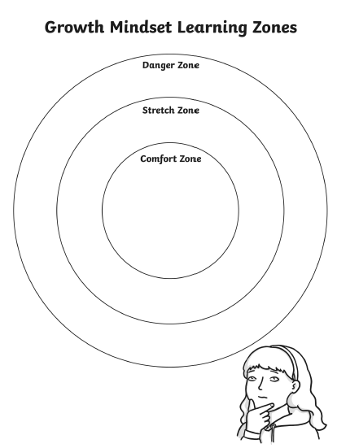

Make a list things that are in your
-comfort zone
-Stretch zone
-Danger zone
2:30 – 3:30 PE (Sport) 5/6s: Mr J. will be on Webex meetings if you need me to answer any questions from 1-2pm TODAY
Grade 3-6 Fitness Circuit/Choice Board Instructions
Each week students will be given a choice board of activities. The centre activities MUST be done with proof of it being done with the fitness circuit checklist. The rest of the activities on the sheet are student's choice. It is required you are doing these for at least 30 minutes a day.

The video - “Fitness Circuit Explanation” will explain how to do it
The video “Fitness Circuit Activities” shows you all the activities and explains how to do them, you are picking 2 activities from each section.
The “Fitness Circuit Checklist” on your MONDAY pack is where you write down the activities you pick. The colours match to the cards.
The following YouTube link will show you exactly how to do each activity. Just look for the name of the activity and it will show you exactly how to do it
https://www.youtube.com/playlist?list=PL2hDszH4XLgW5v_wEa2onDEThj7TuusxQ
Complete your chosen 12 fitness activities twice a week, this is your main P.E task for the week and MUST be completed and recorded.
You are doing each activity for a minute at a time, making sure you have a minute break in between.
When you are not doing your Fitness Circuit, you are to do your CHOICE BOARD which is at the bottom of your MONDAY activities pack.
At the end of the week, send your work to me either on Xuno Family app or email. Send a few photos of you doing your activities!
My email: Andreas.Jordanidis@education.vic.gov.au

