Friday
Week 5
9.15- 10.00 am – Literacy- Both spelling and chapter Book.
Reading – Reading Eggspress
Chapter Books and Comprehension Activity
https://readingeggs.com.au/
Complete assigned tasks

9.15- 10.00 am - Literacy
Reading Eggspress – Spelling
https://readingeggs.com.au/
Log into readingeggspress to find your assigned lesson
Yellow- Lesson 133
Suffixes ous
Orange- Lesson – 167
Suffixes ment, ship, hood.

10:00 – 11.00 am – Numeracy- Khoots with
Ms Starr
Room Number will be given out at roll call.

11:30 – 12:30- INQUIRY

How to research properly on the internet.

Keep in mind the information that you learnt during today’s mini lesson you need to
research any animal that you want. You need to find three reliable websites that each
provide the same information. This way you have supported your facts.
See the example below (please choose a different animal)
Website | Copy of fact
 | The name orangutan means "man of the forest" in the Malay language.
https://www.orangutan.org.au/about-orangutans/orangutan-facts/ | In Malay and Indonesian orang means "person" and utan is derived from hutan, which means "forest." Thus, orangutan literally means "person of the forest."

Animal:

Website | Copy of fact

12:30 to 1:20pm

Finish Off Activities – Time to
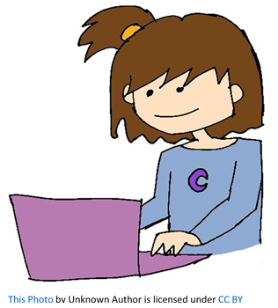
complete your set work for the week.

2:30 – 3:30 PE (Sport)
Grade 3-6 Fitness Circuit/Choice Board Instructions
Each week students will be given a choice board of activities. The centre activities MUST be done with proof of it being done with the fitness circuit checklist. The rest of the activities on the sheet are student's choice. It is required you are doing these for at least 30 minutes a day.

The video - “Fitness Circuit Explanation” will explain how to do it
The video “Fitness Circuit Activities” shows you all the activities and explains how to do them, you are picking 2 activities from each section.
The “Fitness Circuit Checklist” on your MONDAY pack is where you write down the activities you pick. The colours match to the cards.
The following YouTube link will show you exactly how to do each activity. Just look for the name of the activity and it will show you exactly how to do it
https://www.youtube.com/playlist?list=PL2hDszH4XLgW5v_wEa2onDEThj7TuusxQ
Complete your chosen 12 fitness activities twice a week, this is your main P.E task for the week and MUST be completed and recorded.
You are doing each activity for a minute at a time, making sure you have a minute break in between.
When you are not doing your Fitness Circuit, you are to do your CHOICE BOARD which is at the bottom of your MONDAY activities pack.
At the end of the week, send your work to me either on Xuno Family app or email. Send a few photos of you doing your activities!
My email: Andreas.Jordanidis@education.vic.gov.au

