Friday- Term 4 – Week 1
9.15- 10.00 am – Writing Legends.

https://www.writinglegends.com/
Select any 2 quick writes from writing legends as your task today, free choice.

Students are to select 2 quick writes form Writing Legends of your own choice for
this session. Complete the writing task on writing legends and your teacher will
give you feedback.

10:00 – 11.00 am – Numeracy- 10.30am: Mini Lesson-
Learning Intension
I will be learning how to round off money to the nearest five cents.
Success Criteria
I will be able to round off change to the nearest 5 cents.

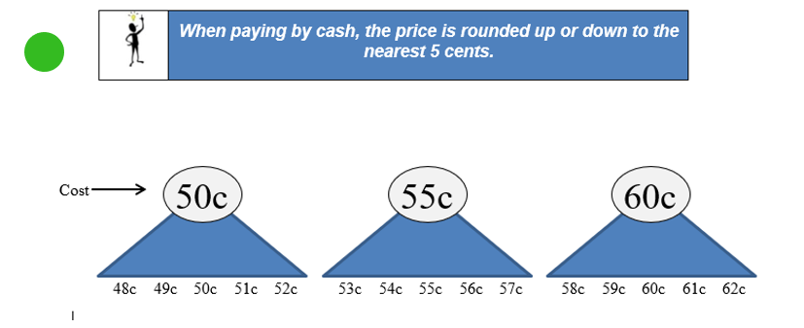
Rounding off money

Australian currency used to include 1 and 2 cent pieces. They were withdrawn from circulation in 1992.
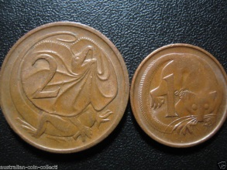
As we no longer have these coins it is important for us to be able to round off money to the nearest 5 cents when we are paying with cash.

For example, if we are going to buy a bar of chocolate that costs $2.23 we cannot give the shopkeeper this exact amount, as we do not have 1 and 2 cent pieces. Therefore, this amount needs to be rounded off to $2.25.

The Rules

Sometimes money will be rounded up and sometimes it will be rounded down.
- Cash amounts ending in 0c or 5c do not change. If you buy something that costs $1.10 or $6.25 there is no need to round off the money you are paying.
- If the number of cents ends in 1c or 2c it is rounded down to 0. Example: $2.52 is rounded down to $2.50.
- If the number of cents ends in 3c or 4c, it is rounded up to the nearest 5c. Example: $7.63 is rounded up to $7.65.
- Cash amounts ending in 6c or 7c are rounded down to the nearest 5c. Example: $6.16 is rounded down to $6.15.
Cash amounts ending in 8c or 9c, round up to the nearest 10c. Example: $10.99 is rounded up to $11.00

Complete these amounts up or down to the nearest 5 cents.

a. | $1.88 = _______ | b. | $1.96 = ________ | c. | $2.99 = _______
d. | $3.19 =_______ | e. | $2.14 = ________ | f. | $7.96 = _______
g. | $2.19 = _______ | h. | $8.76 = _______ | i. | $3.11 = _______
j. | $3.82= _______ | k. | $4.98 = _______ | l. | $2.01 = _______

11:30 – 1.20-Student Choice Project.
This project will be presented in week 5.

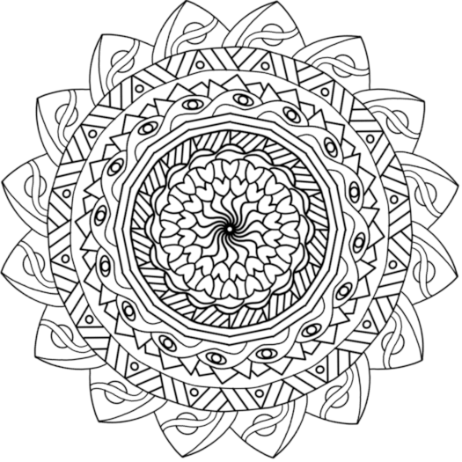

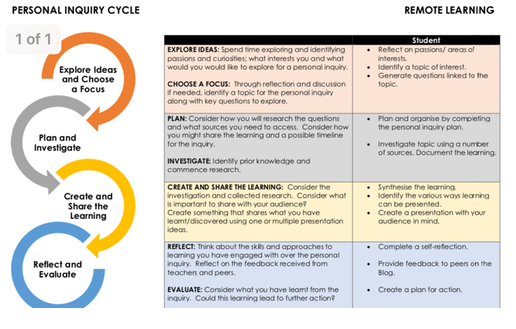

PE - Grade 3-6 Term 4 Week 1
Welcome to Term 4 Grade 3-6's!
In preperation to being back to face to face learning in Week 2, this week has a small focus on soccer which is what we will be looking at when we get back to school.
On your choice board, make sure you complete the blue section in the middle. Rest of the week do the other activities as well.

You need to be doing at least 30 minutes a day of Physical Activity.
This is what I need by the end of the week to say you have completed the weeks work:
1) Blue Section of choice board complete.
2) Highlighted and labelled what day you did the different choice board activities.
3) At least one photo of you doing your activities so I have proof.

You can either Xuno or Email me your work. If you are in Grade 5/6 you can also use Microsoft Teams.
Email: Andreas.Jordanidis@education.vic.gov.au

I have made it simple and easy for the last week of remote learning. I look forward to seeing you all in week 2 for when we can finally do some P.E at school together!
Carry all the groceries in for your parents, one piece at a time. | Create an obstacle course at home. Challenge your family to do it. | Who in your family can do the most push ups? | Burpees – Do 20 burpees.  Take breaks if it is too hard
Just dance  Complete 2 Just Dance videos  Click Here | See who in your family can plank for the longest | Use an empty bottle as your target, place it anywhere in your house and try to hit it with a pair of socks. Try some trick shots! | How long can you keep your arms stretched above your head?
Work out -  Compelte this workout at home  Plank for 1 minute  20 jumping jacks  20 push ups  20 sit ups | Kick a ball in a small goal 30 times in a row.  Complete 30 passes with a family member. |  | Click Here  Complete one of these meditation videos. Relax and enjoy!
Yoga Complete a yoga video from this playlist  Click Here | Alphabet challenge  30 seconds per letter  Try and find an item with every letter of the alphabet.  If you have done this one before, you must find different items! | Scavenger Hunt.  Put 2 minutes on a timer – Collect the following items: A vegetable, something round, something metal and something blue. Challenge your family! | Play follow the leader with a sibling or parent
Tik Tok Dance challenge  Learn 3 Tik Tok dances and recreate them! | Go for a bike ride/walk your dog | Take your dirty clothes out into the laundry one piece of clothing at a time | Time yourself to see how long it takes for you to clean a room in your house!

