Grade 3/4  Week 7 | Remote Learning:  Thursday 3rd September
Session 1  Inquiry | Learning Intention:  We are learning about natural landforms in Australia  Success Criteria:  -I can label different features of my chosen landform  -I can create a landform in one of the ways listed below  -I can send a picture or power-PowerPoint presentation of my project to my teacher  See Monday for worksheet
Session 2  Numeracy | Studyladder  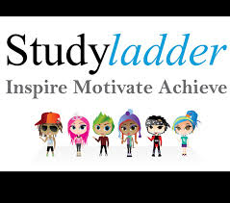  Learning Intention:  We are learning to understand the relationship between multiplication and division  Success Criteria:  I can complete the individual tasks as set by my teacher  Activity: www.studyladder.com.au  - Students to work independently on assigned study ladder tasks. Students have been assigned work by their teachers.  - Visit the studyladder website and log in with your username and password.  - If you cannot remember your log in details, contact your teacher and you will be given one.
Session 3  Literacy | Writing  We are learning about the DAINTREE RAINFOREST  I can read the text and then answer the questions to show my understanding  Week 7 session 2- see below
Session 4  PE | Mr J will be on Webex Today from 2pm to answer any questions you may have about this weeks lesson.  Grade 3-6 Term 3 Dance Unit Instructions  For the last 4 weeks of term, the grade 3 to 6 students will be completing some dance routines. Dance is a great way to improve your timing, as well as endurance, flexibility and maintaining fitness overall. You will be continuing the choice boards as well – 30 minutes a day!  Each week you will have 2 videos you need to watch and complete. The first one being a warmup video (with stretches etc), the other being a dance routine video.  You will also be asked to complete a reflection sheet and your usual choice board each week and send it to me. These will be found on your MONDAY homework. 1 day you do your dance, the other 4 days you are doing your choice board.  To complete each weeks work you must do the follow.  1) Take at least 1 photo or video of you attempting the dance routine  2) Fill in and complete the reflection sheet.  3) Fill in your choice board with what activities you did.  When those 3 are done you need to send the work to me either over Xuno, Email or for Grade 5/6 over Microsoft Teams.  Email: Andreas.Jordanidis@education.vic.gov.au

TASK: Read the text to learn about the DAINTREE RAINFOREST and then answer the questions to show your understanding
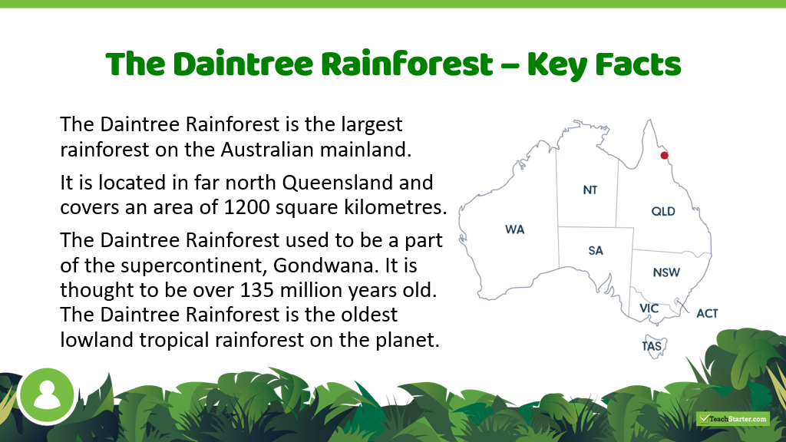
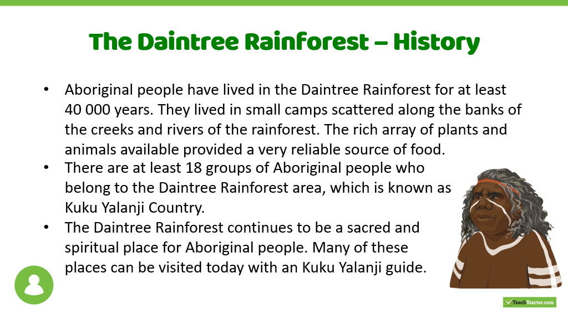

Plants and Animals
In the protected Daintree Rainforest, there are many types of animals and plants. In all there are over 12,000 types of insects (including 135 types of dung beetles) and 3,000 types of plants.

This rainforest also has 663 types of vertebrate animals or animals that have a backbone or spine. There are some rare animals in the Daintree Rainforest.
One interesting and endangered animal that is in the Rainforest is the cassowary, which is a giant bird.
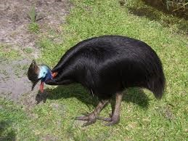
Cassowary Bird
Other animals include the white-lipped tree frog, Ulysses butterfly, and the Bennett's tree kangaroo.
However, between 300 and 400 of the animals in the Daintree Rainforest are threatened or rare. There are many types of plants and animals that are only found in this rainforest, but they also need to be protected.
There are also a lot of plants in the rainforest. One of the plants is known as the idiot fruit, which was re-discovered in 1971. It was on the earth when dinosaurs lived. People believed the plant was gone forever. Another plant that is in the Daintree Rainforest is the chocolate pudding fruit, which is a tasty fruit.

Remember to go back to the text to check for your answers. Write your answers in FULL SENTENCES
- Where is the Daintree Rainforest?

- How big is it and how old do we think it might be?

- What is the Aboriginal name for the area?

- Why was the area a good place for Aboriginal people to live?

- Name five different animals that live in the Daintree.

- There are some unusually named flora in the Daintree, what are two of them?

- Why do so many of the fauna and flora need protection?

- What is another interesting fact you learnt reading this text?

