|  |  |
| --- | --- |
| **Grade 3/4**  **Week 7** | **Remote Learning:**  **Monday 31st August** |
| **Session 1**  Numeracy | **Multiplication and Division & Groups and Arrays**  Learning Intention:  We are learning to understand the relationship between multiplication and division  Success Criteria:  I can share what I know about multiplication and division with my teacher  See below for worksheets |
| **Session 2**  Literacy | **Reading**    Go to Reading [Eggspress](https://sso.readingeggs.com/login?client_id=eac7762a79132dfba987a412e4861c105549fdf1&idp=d0797975a160eeec142b30cd3705fe6ee3eafec9&redirect_uri=https%3A%2F%2Fstudent.readingeggspress.com%2Foauth%2Flogin%3Fidp%3Dd0797975a160eeec142b30cd3705fe6ee3eafec9%26scope%3Dblake&response_type=code&scope=blake&state=1e4d3374f82c5c8d725bd1326088accd5ca2e6f323883e71) and complete either   * Comprehension * Spelling or * Read a book |
| **Session 3**  Inquiry | Learning Intention:  We are learning about natural landforms in Australia  Success Criteria:  -I can label different features of my chosen landform  -I can create a landform in one of the ways listed below  -I can send a picture or power-PowerPoint presentation of my project to my teacher  See below for worksheet |
| **Session 4**  PE | **Grade 3-6 Term 3 Dance Unit Instructions**  For the last 4 weeks of term, the grade 3 to 6 students will be completing some dance routines. Dance is a great way to improve your timing, as well as endurance, flexibility and maintaining fitness overall. **You will be continuing the choice boards as well – 30 minutes a day!**  Each week you will have 2 videos you need to watch and complete. The first one being a warmup video (with stretches etc), the other being a dance routine video.  You will also be asked to complete a reflection sheet and your usual choice board each week and send it to me. These will be found on **TODAY’s document**. 1 day you do your dance, the other 4 days you are doing your choice board.  To complete each weeks work you **must** do the follow.  **1)** Take at least 1 photo or video of you attempting the dance routine  **2)** Fill in and complete the reflection sheet.  **3)** Fill in your choice board with what activities you did.  When those 3 are done you need to send the work to me either over Xuno, Email or for Grade 5/6 over Microsoft Teams.  Email: [Andreas.Jordanidis@education.vic.gov.au](mailto:Andreas.Jordanidis@education.vic.gov.au)  Have a go at these videos, the warmup is to get your body ready. Replay the dance video as much as needed to get the moves right. Make sure you are doing it somewhere with a lot of space!  Warm up:<https://www.youtube.com/watch?v=dRQf3yFXO1Y>  Dance Video: <https://www.youtube.com/watch?v=Kt0b00LQo-g>  **PE - Dance Reflection Sheet**  **Name: Week:**  1) Did you enjoy the dance video this week? Why/Why not?    2) How did you feel after you completed the videos? |

**Year 3/4 Inquiry week 7**

Learning Intention:

We are learning about natural landforms in Australia

Success Criteria:

-I can label different features of my chosen landform

-I can create a landform in one of the ways listed below

-I can send a picture or power-PowerPoint presentation of my project to my teacher

**Natural Landform Project**

Activity:

Your task is to represent a landform that you have learnt about during Literacy and Inquiry Sessions this term. You can choose how you want to represent a landform of your choice from the list below or if you have another idea, talk to your teacher during a webex meeting or email them.

Examples of landforms

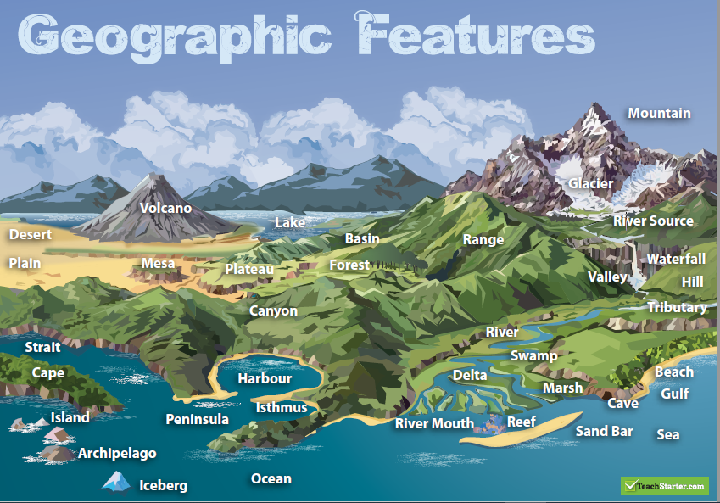

**Step 1. Choose a place that you found interesting**

*For example:*

*Uluru, Daintree Rainforest, Kathrine Gorge, The Pinnacles, Monkey Mia, The Three Sisters, Australian Alps, Coober Pedy, McDonnell Rangers, The Great Barrier Reef, The 12 Apostles or another place you are have researched.*

**2. Look back over the book Are We There Yet? and various videos from Inquiry and Literacy sessions for information. Make notes and look at pictures of the place you have chosen.**

**3. Fill in the planner below.**

Some suggestions how you can present your project:

* power point presentation about the place you have chosen with important facts that you have learnt about.
* diorama of your chosen landform using any materials found inside and outside your home. (See example below)
* a video advertisement describing the place and selling it to tourists
* a painting or detailed drawing including fauna and flora around the place

a collage – a picture made of various materials such as bits of paper, cloth, or wood and glued onto the surface. (See example below)

an information poster

* other – talk to your teacher about it

**Some examples of materials you can use**

-leaves, rocks, sticks, grass, etc. to create an animal

-cardboard, string, clay/playdough, paper, glue, cotton wool

-newspapers, magazines, poster paper

If you are looking for some ideas on how to make a diorama, have a look at the videos below. Remember you are choosing only one place in Australia.

<https://www.youtube.com/watch?v=MghSSSoZ9Jw>

<https://www.youtube.com/watch?v=MuIH1yrZz0U>

<https://www.youtube.com/watch?v=WIJW0lq1GAY>

|  |  |
| --- | --- |
|  | **Collage Example** |

Name: Date:

**Project Planner**

Design your own natural landform by completing this planner.

|  |  |
| --- | --- |
| Sketch | Description/facts |
| Quick sketch of your chosen landform, include labelling of physical features  (no colouring in, remember it’s just a plan) | Description of your landform  Where is it, what it is, why is it interesting, what animals live there, what plants grow there, other interesting facts |
|  |  |
| List of materials needed: | Checklist   1. ShapeI completed my planner 2. ShapeI have labelled and named my landform 3. ShapeI made a list of materials I needed 4. ShapeI have described the physical features of my landform 5. ShapeI have included flora and fauna |

**REMEMBER ONCE YOU HAVE FINISHED YOUR PROJECT, SEND THIS PAGE AND A PICTURE OF YOU PROJECT TO YOUR TEACHER. IF YOU ARE DOING A POWER POINT JUST SAVE IT ON YOUR COMPUTER AND THEN ATTACH AND EMAIL TO YPUR TEACHER. HAVE FUN!!**

**MATHS**

*SO, THIS IS WHAT I WANT YOU TO KNOW – ABOUT WHAT I KNOW -ABOUT DIVISION AND MULTIPLICATION*

|  |  |  |
| --- | --- | --- |
| NAME  DATE | Words related to multiplication: |  |
| Words related to division: |

I can write a multiplication story and show you the equation on how to solve it.

I can write a division story and show you the equation on how to solve it.

I can show you how multiplication and division are related

|  |  |
| --- | --- |
| **This is something I would like to learn, or I am confused about:** | |
| **Multiplication** | **Division** |

**Appendix 2 – Making groups**

|  |  |  |  |
| --- | --- | --- | --- |
| **Make** | **Draw it** | **How many altogether?** | **How did you work it out?** |
| 5 groups of 2 |  |  |  |
| 3 groups of 5 |  |  |  |
| 4 groups of 10 |  |  |  |

**Appe****ndix 3 – Arrays**

Here is a box of stars. Show and explain **all** the ways you could find the total?









|  |
| --- |
| How can you describe how the stars are packed into the box?  How many stars in total would there be in two boxes? – show how you worked it out  How many in 4 boxes? – show how you worked it out |

My explanation to how I worked out how many stars there were:

|  |  |  |  |
| --- | --- | --- | --- |
| Burpees – Do 20 burpees.  Take breaks if it is too hard | Play simon says with your family.  Make it a challenge! | Go for a walk with your family or a bike ride.  Not too far away! | Clean the whole house for your family. See how much you can clean in 30 minutes! |
| Yoga Complete a yoga video from this playlist  [Click here](https://www.youtube.com/playlist?list=PLtKFn2-K_dbCDKliizdMiPPo2vJipiTjI) | Time how long it takes to clean your room. | Play a game of closest to pin. See who can throw a pair of socks closest to an empty bottle without knocking it over | How long can you balance on one foot for? |
| Scavenger Hunt  Find: Plastic Cup, Yellow Flower, Blue sock, an item beginning with a,f,j,s and w | **Dance Routine!** **Complete your warm up and dance videos**  **Fill in your Reflection Sheet**  **Do the video as many times as possible to get the moves correct**  **Just have a go!** | | Create a game.  Create a game with rules for your family to play |
| Just dance Complete 2 Just Dance videos  [Click here](https://www.youtube.com/justdance/videos?view=0&sort=dd&flow=grid) | Throw a ball against the wall and catch it 20 times in a row.  Challenge yourself to do it one handed | Create your name using only your body!  You may need a brother or sister to help you | [Click here](https://www.youtube.com/results?search_query=kids+meditation)  Complete one of these meditation videos. Relax and enjoy! |
| Wall sit challenge  Who can Wall sit for the longest without falling? | Follow the leader – Play follow the leader with your family to do different movements | Trick Shot challenge,  Place a plastic cup somewhere in the room, your aim to try and find the hardest spot to throw a pair of socks into the cup. | Sprints – Do 15 sprints up and down your driveway |

**PE Choice Board week 7**