Grade 3/4  Week 6 | Remote Learning:  Thursday 27th August
Session 1  Inquiry | Learning Intention:  We are learning about different climates in Australia and how it affects the vegetation (flora).  Success criteria:  We are successful if we can:  -match pictures to description  -choose 2 pictures and describe the vegetation  See below for worksheets
Session 2  Numeracy | Studyladder  Learning Intention:  We are learning to use location  Success Criteria:  I can complete the individual tasks as set by my teacher  Activity: www.studyladder.com.au  - Students to work independently on assigned study ladder tasks. Students have been assigned work by their teachers.  - Visit the studyladder website and log in with your username and password.  - If you cannot remember your log in details, contact your teacher and you will be given one.
Session 3  Literacy | Writing  Click on the link below:  Are We There Yet? By Alison Lester
Session 4  PE | Grade 3-6 Term 3 Dance Unit Instructions  For the last 4 weeks of term, the grade 3 to 6 students will be completing some dance routines. Dance is a great way to improve your timing, as well as endurance, flexibility and maintaining fitness overall. You will be continuing the choice boards as well – 30 minutes a day!  Each week you will have 2 videos you need to watch and complete. The first one being a warmup video (with stretches etc), the other being a dance routine video.  You will also be asked to complete a reflection sheet and your usual choice board each week and send it to me. These will be found on your MONDAY homework.  To complete each weeks work you must do the follow.  1) Take at least 1 photo or video of you attempting the dance routine  2) Fill in and complete the reflection sheet.  3) Fill in your choice board with what activities you did.  When those 3 are done you need to send the work to me either over Xuno, Email or for Grade 5/6 over Microsoft Teams.  Email: Andreas.Jordanidis@education.vic.gov.au  Each week, you will have a web ex time you can meet with me to ask me questions.  3-4s: I will be on WebEx meetings if you need me to answer any questions from 2-3pm on a Thursday

Inquiry Session 2 week 6

Places - Australia
Climate and Vegetation in Australia

Learning Intention:
We are learning about different climates in Australia and how it affects the vegetation (flora).
Success criteria:
We are successful if we can:
-match pictures to description
-choose 2 pictures and describe the vegetation

There is a close link between climate and vegetation. These photographs show the landscape and vegetation typical of each climate zone.

Study the photographs of vegetation types below. Identify the
photograph that best matches the following climate types. Write the name of the place on the line.

TASK 1
a. Arid ______________________________________________________
b. Tropical ___________________________________________________
c. Cool temperate _____________________________________________
d. Warn temperate ____________________________________________
e. cold temperature____________________________________________

Daintree Rainforest, North Queensland
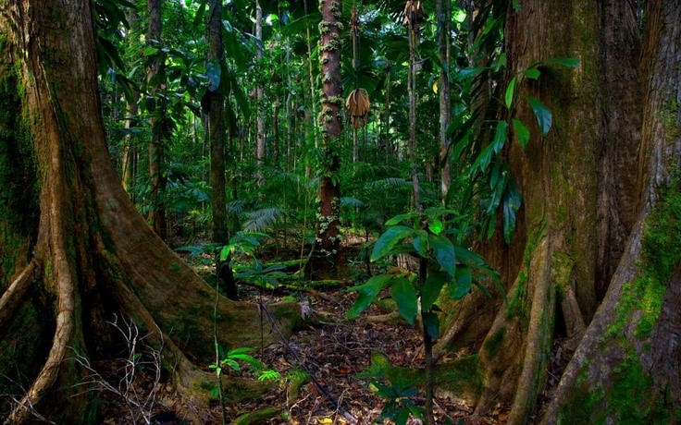

Cradle Mountain, Tasmania
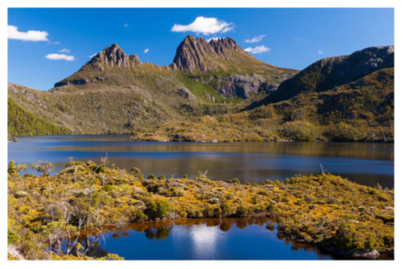

Simpson Desert, Central Australia
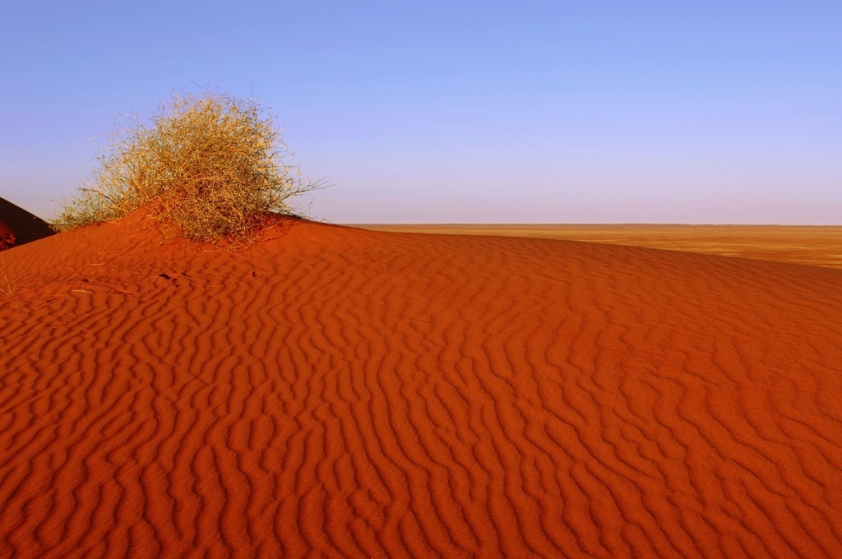

Australia Alps, Victoria
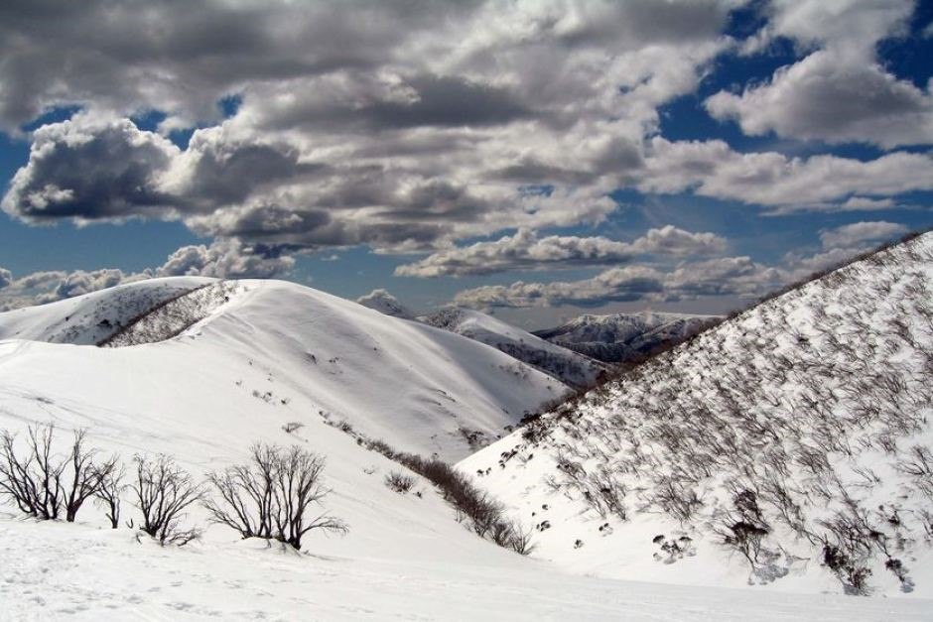

Eucalyptus Forest, New South Wales
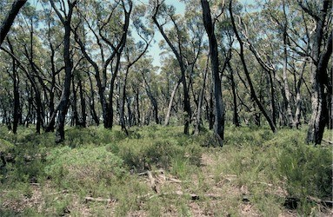

Task 2
Choose 2 of the pictures and describe what you notice about the vegetation in each one.
Picture One | Picture Two

