Grade 3/4  Week 4 | Remote Learning:  Monday 10th August
Session 1  Numeracy | Subtraction  We are learning how to use different strategies to solve subtraction problems  Success Criteria:  I can use the jump strategy to solve subtraction equations  I can use a 100s chart to solve simple subtraction equations  See below for worksheets
Session 2  Literacy | Reading  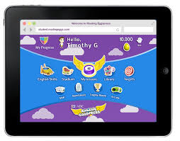  Go to Reading Eggspress and complete either  - Comprehension  - Spelling or  - Read a book
Session 3  Inquiry | Places- AUSTRALIA  Learning Intention:  We are learning about the Australian climate  Success Criteria:  We are successful if we can:  -read a map using the map key  -write 3 observations about the map  -answer set questions using full sentences  See below for worksheet
Session 4  PE | Grade 3-6 Fitness Circuit/Choice Board Instructions  Each week students will be given a choice board of activities. The centre activities MUST be done with proof of it being done with the fitness circuit checklist. The rest of the activities on the sheet are student's choice. It is required you are doing these for at least 30 minutes a day.  The video - “Fitness Circuit Explanation” will explain how to do it  The video “Fitness Circuit Activities” shows you all the activities and explains how to do them, you are picking 2 activities from each section.  The “Fitness Circuit Checklist” on your MONDAY pack is where you write down the activities you pick. The colours match to the cards.  The following YouTube link will show you exactly how to do each activity. Just look for the name of the activity and it will show you exactly how to do it  https://www.youtube.com/playlist?list=PL2hDszH4XLgW5v_wEa2onDEThj7TuusxQ  Complete your chosen 12 fitness activities twice a week, this is your main P.E task for the week and MUST be completed and recorded.  You are doing each activity for a minute at a time, making sure you have a minute break in between.  When you are not doing your Fitness Circuit, you are to do your CHOICE BOARD which is at the bottom this page (MONDAY activities pack).  At the end of the week, send your work to me either on XUNO app or email. Send a few photos of you doing your activities!  My email: Andreas.Jordanidis@education.vic.gov.au

MATHS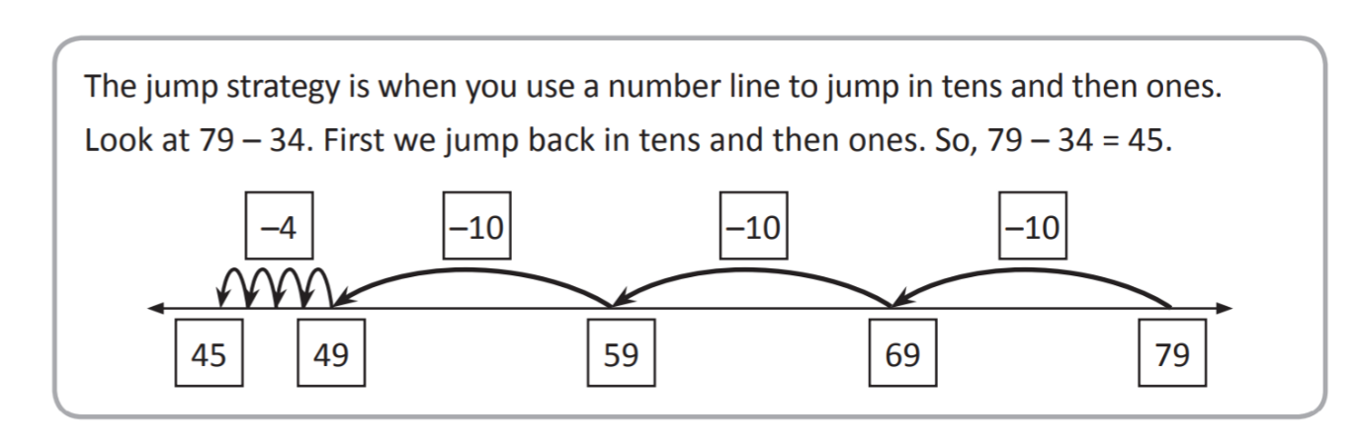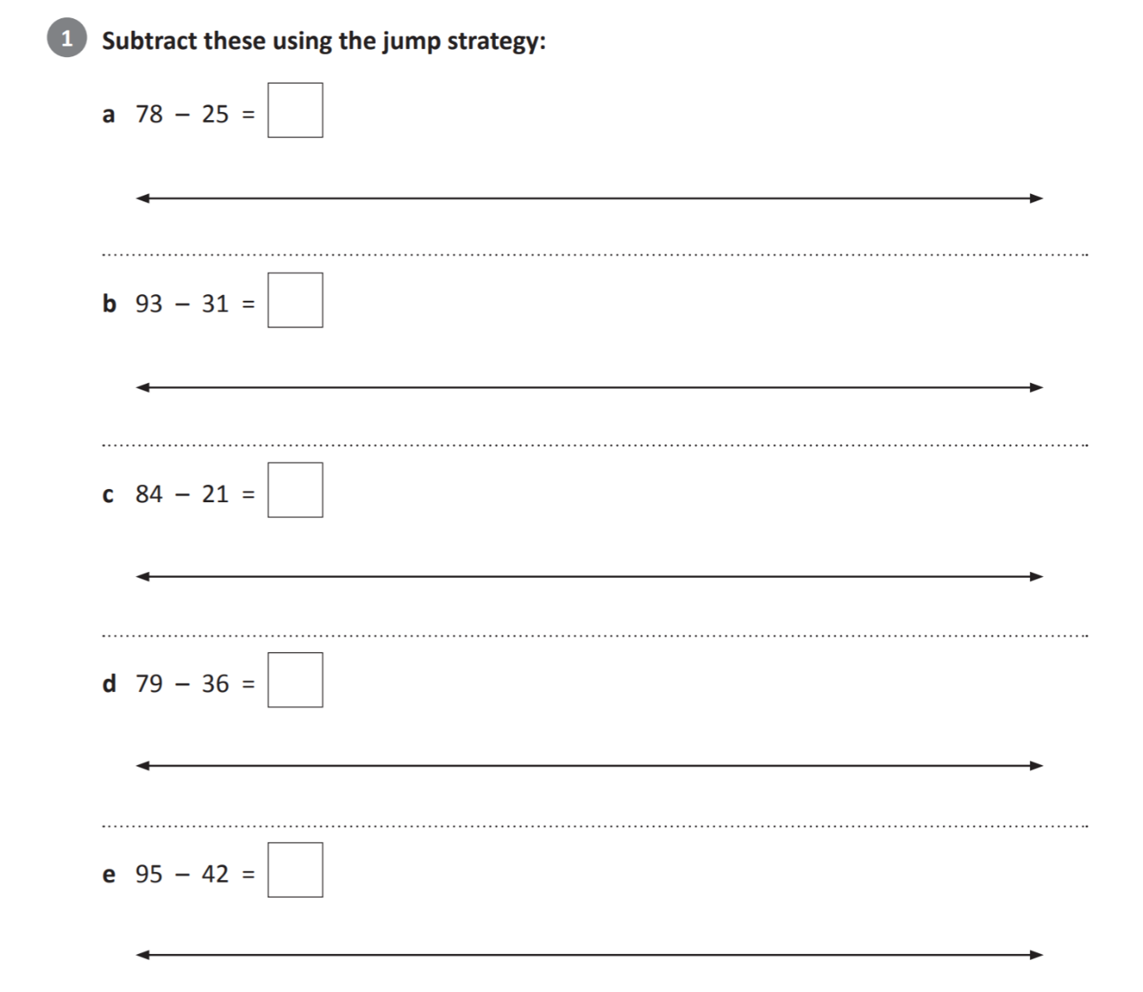
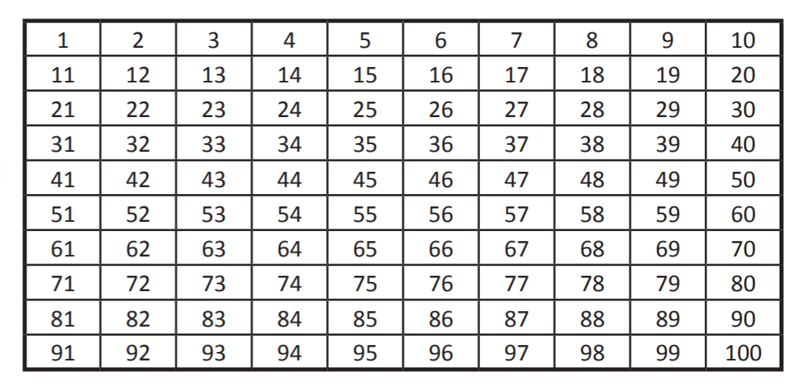

You can check your answers by using the 100’s chart

Try the solve these equations using the 100’s chart

89 – 11 =

27 – 15 =

75 – 12 =

32 – 20 =

68 – 25 =

56 – 32 =

INQUIRY Australia
Session 1

Australia is the lowest, flattest and driest continent.
Nearly 20 per cent of Australia's land mass is a desert. Rainfall across Australia is varied.
Climates are different around Australia. We have tropical rainforests, deserts,
cool temperature forests and snow-covered mountains.
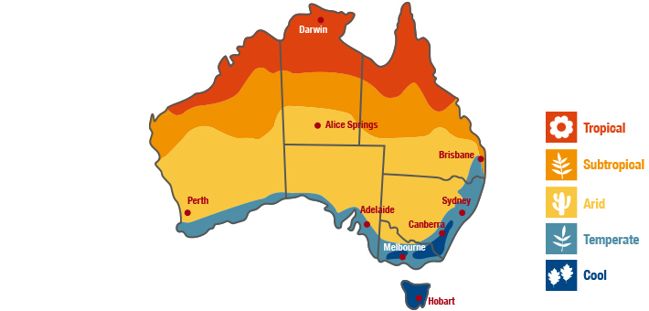
Vocabulary
Find the meaning of the words used in map key above. Google the meaning.
Temperate -
Tropical -
Subtropical- under the tropics or next to
Arid-
Cool-

Study the map above. What do you notice about the climate in different parts of AUSTRALIA? Explain your observations using full sentences. Use map key in the top right-hand corner to help you (the colours help you to locate different climates on the map)
For example: I notice that it is very hot and humid in northern parts of Australia.

1.

2.

3.

Think about what you learnt last week about the Pinnacles in Western Australia. What sort of climate would you encounter if you went there?

What sort of climate does Darwin have?

What part of Australia would you like to live in? Explain why you would choose to live there?

Most Australians live around the eastern coast of Australia. Why do you think that is?

1 minute for each activity
1 minute break in between them

PE Fitness Circuit Checklist: Week 4
Name:  Room: | Attempt 1 | Attempt 2
Whole Body Strength

Core Strength

Arm Strength

Leg Strength

Stamina

Flexibility & Balance

Whole Body

Core Strength

Arm Strength

Leg Strength

Stamina

Flexibility & Balance

PE CHOICE BOARD

Bounce a basketball 100 times with both hands. | Throw and catch a ball against a wall up to 50 times | Towel Target Points game.  Grab some socks, put a towel on the floor, vs someone in see who can get all their socks on the towel | Hang out the washing for your family.
Clean your whole house for your family. Vacuum and all! | Who can do the most push ups? | Play a game of closest to pin. See who can throw a pair of socks closest to an empty bottle without knocking it over | Yoga – go to Youtube and complete a Yoga video
Bottle Bowling  Play a game of bowling with some bottles and a small ball. | FOCUS ON FITNESS  Complete your fitness circuit twice this week.  Did you change your activities or keep the same?  Why/Why not? |  | Set up a goal in the backyard – kick a ball in the goal 20 times in a row.
Throw a tennis ball high in the air,  How many times can you clap before you catch it? | Throw a ball against the wall and catch it 20 times in a row.  Challenge yourself to do it one handed | Create a game in your house, it can be who can score the most points, who can collect the most of a certain colour.  Challenge your family to it. | Meditate for 5 minutes, clothes your eyes, lay down, try and clear your mind. Relaxing music will help.
How long can you do a wall sit for?  Challenge your family to it! | Do 4 different Just Dance Videos on YouTube  Ask your family to join in | Trick Shot challenge,  Place a plastic cup somewhere in the room, your aim to try and find the hardest spot to throw a pair of socks into the cup. | Go for a bike ride or walk your dog!

