Grade 3/4  Week 2 | Remote Learning:  Tuesday 28th July
Session 1  Literacy | Writing  CLICK HERE TO OPEN YOUR WRITING SESSION 1
Session 2  Numeracy | Telling time to half hour, quarter to and quarter past  (WebEx mini lesson): Your worksheets will be explained during the WebEx session.  Success criteria:  We will be successful if we are able to tell time on an analogue clock.  See worksheets below
Session 3  Art | Click HERE for your Art Lesson for this week from Mrs KARACA
Session 4  PE | Grade 3-6 Fitness Circuit/Choice Board Instructions  Each week students will be given a choice board of activities. The centre activities MUST be done with proof of it being done with the fitness circuit checklist. The rest of the activities on the sheet are student's choice. It is required you are doing these for at least 30 minutes a day.  The video - “Fitness Circuit Explanation” will explain how to do it  The video “Fitness Circuit Activities” shows you all the activities and explains how to do them, you are picking 2 activities from each section.  The “Fitness Circuit Checklist” on your MONDAY pack is where you write down the activities you pick. The colours match to the cards.  The following YouTube link will show you exactly how to do each activity. Just look for the name of the activity and it will show you exactly how to do it  https://www.youtube.com/playlist?list=PL2hDszH4XLgW5v_wEa2onDEThj7TuusxQ  Complete your chosen 12 fitness activities twice a week, this is your main P.E task for the week and MUST be completed and recorded.  You are doing each activity for a minute at a time, making sure you have a minute break in between.  When you are not doing your Fitness Circuit, you are to do your CHOICE BOARD which is at the bottom of your MONDAY activities pack.  At the end of the week, send your work to me either on flexibuzz or email. Send a few photos of you doing your activities!  My email: Andreas.Jordanidis@education.vic.gov.au

NUMERACY
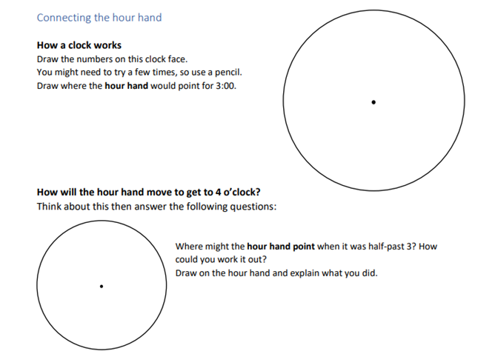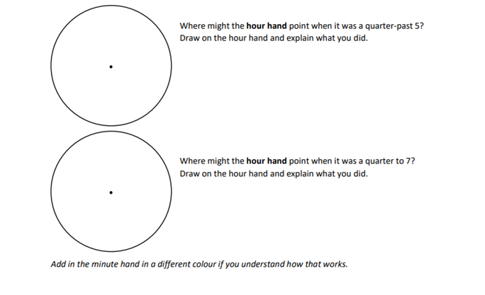
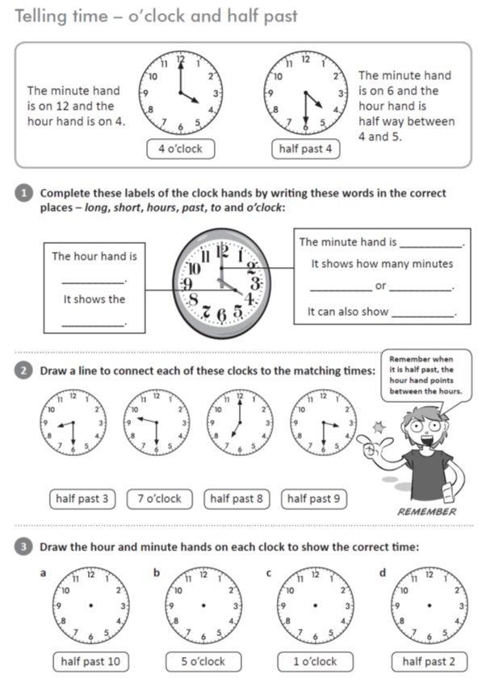

PE CHOICE BOARD
Carry all the groceries in for your parents, one piece at a time. | Create an obstacle course at home. Challenge your family to do it. | Who in your family can do the most push ups? | Create some dance moves to your favourite song
Research a yoga video for kids on YouTube.  Have a go at doing it! | See who in your family can plank for the longest | Use an empty bottle as your target, place it anywhere in your house and try to hit it with a pair of socks. Try some trick shots! | How long can you keep your arms stretched above your head?
Alphabet challenge  30 seconds per letter  Try and find an item with every letter of the alphabet. | FOCUS ON FITNESS  Complete your fitness circuit twice this week.  Did you change your activities or keep the same?  Why/Why not? |  | Balance on one leg for as long as you can.  Challenge your family to beat it
Lily Pads  Put cushions and pillows on the floor, jump from one to another | Make a small goal – aim to kick a ball into the goal 20 times in a row. | Animal Charades  Challenge a sibling or parent to work out what animal you are being, they do the same and you guess! | Play follow the leader with a sibling or parent
Kick a soccer ball against the wall or pass to a family member | Go for a bike ride/walk your dog | Take your dirty clothes out into the laundry one piece of clothing at a time | See how long you can walk with a book on your head.

