Grade 3/4  Week 5 | Remote Learning:  Friday 21st August
Session 1  Literacy | Reading  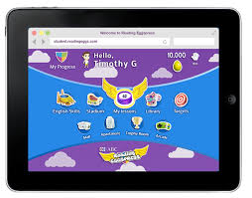  Go to Reading Eggspress and complete either  - Comprehension  - Spelling or  - Read a book
Session 2  Numeracy | Maths- investigations and revision  Learning Intention:  We are learning to use our mathematical knowledge to solve various problems  Success Criteria:  I can show my mathematical understanding to solve and explain how I solved a given problem.  I attempted the super challenge  See below for worksheets
Session 3  SHARE | Yoga  Learning Intentions:  We are learning to relax and exercise  Success Criteria:  I can complete the worksheet provided by my teacher  See below for worksheet
Session 4  PE | Grade 3-6 Fitness Circuit/Choice Board Instructions  Each week students will be given a choice board of activities. The centre activities MUST be done with proof of it being done with the fitness circuit checklist. The rest of the activities on the sheet are student's choice. It is required you are doing these for at least 30 minutes a day.  The video - “Fitness Circuit Explanation” will explain how to do it  The video “Fitness Circuit Activities” shows you all the activities and explains how to do them, you are picking 2 activities from each section.  The “Fitness Circuit Checklist” on your MONDAY pack is where you write down the activities you pick. The colours match to the cards.  The following YouTube link will show you exactly how to do each activity. Just look for the name of the activity and it will show you exactly how to do it  https://www.youtube.com/playlist?list=PL2hDszH4XLgW5v_wEa2onDEThj7TuusxQ  Complete your chosen 12 fitness activities twice a week, this is your main P.E task for the week and MUST be completed and recorded.  You are doing each activity for a minute at a time, making sure you have a minute break in between.  When you are not doing your Fitness Circuit, you are to do your CHOICE BOARD which is at the bottom of your MONDAY activities pack.  At the end of the week, send your work to me either on Xuno Family app or email. Send a few photos of you doing your activities!  My email: Andreas.Jordanidis@education.vic.gov.au  3-4s: I will be on Webex meetings if you need me to answer any questions from 2-3pm on a Thursday  5/6s: I will be on Webex meetings if you need me to answer any questions from 1-2pm on a Tuesday  My meeting number can be found on Xuno, messaged to you.

Maths – mathematical thinking

What number is at the blue cross?

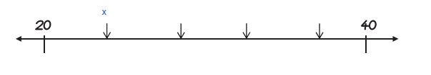
How did you come up with this number?

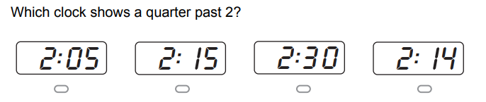

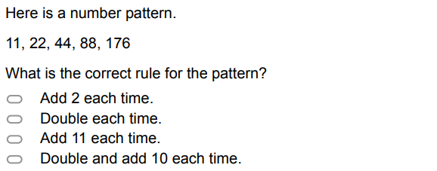
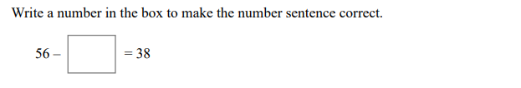

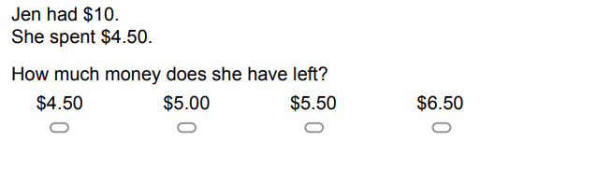

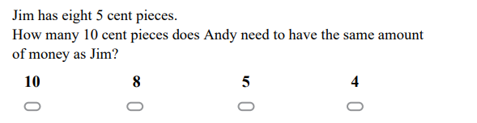

Super Challenge – we dare you!!

There are 10 millimetre in 1 centimetre

So half ( ½) a centimetre would be 5 millimetres

What is the length of the pencil?

What is the length of the ruler?

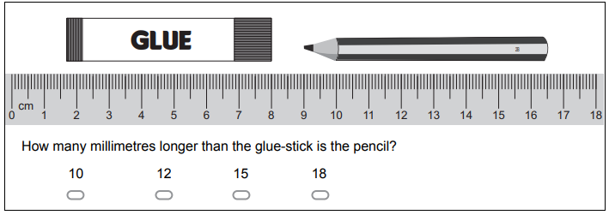

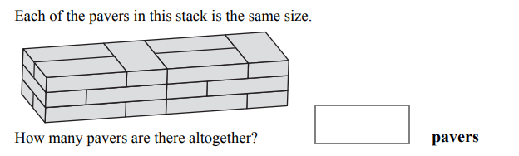

Don’t forget the pavers that you cannot see!

Remote Learning WEEK 5 TERM 3 Grade 3/4
SHARE
Mindfulness

Activity: Sonic Yoga.

What is Yoga?
Yoga is practicing exercise and stretching to keep mindful and relaxed.
Today, you will do a Sonic the Hedgehog exercise activity to practice being mindful.
- Set up a space in the house where you have room to move. This might be in the living room or even outside in the backyard.

- Visit the YouTube link to practice a yoga activity. You’ll need to put the volume up and place your iPad or Laptop far away enough so that you don’t trip on it: https://www.youtube.com/watch?v=QM8NjfCfOg0

- After finishing the exercises, complete the table below.
How I feel before doing yoga | My favourite sonic stretch (you may draw it if you like).

How I feel after doing yoga

