Thursday Literacy
Read the information about koalas 2 times and write a report on Koalas. Use two pages in your book. Copy the report into your workbooks. 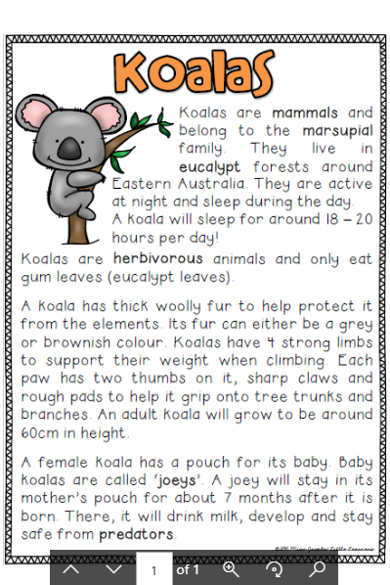

____________ Report

What group do koalas belong to? |  | What do they look like?
What do they eat? |  | Where do they live?
Write Something interesting about koalas. | Draw a picture of a koala and lable body parts.

Thursday Numeracy
Watch the video below
https://www.youtube.com/watch?v=0eAyvTcIkWQ
We are learning to tell the time to quarter to.
Copy the clock faces into your workbook and show the hands for quarter to. The long hand must be on the 9 and the short hand on the hour.
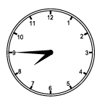quarter to 8
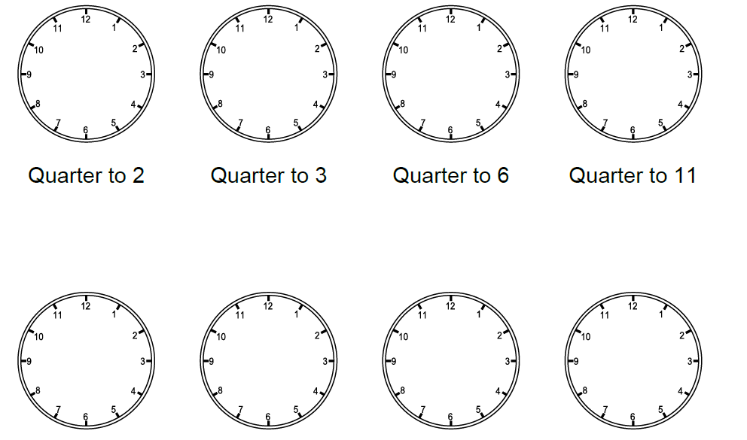
Quarter to 7 Quarter to 9 Quarter to 1 Quarter to 8
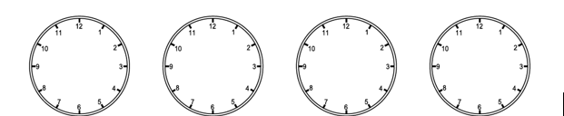
Quarter to 2 Quarter to 4 Quarter to 11 Quarter to 7

