Friday Literacy
https://www.youtube.com/watch?v=NK8_Tvu6bJk
Watch the digraphs video
Copy the sh digraph words and draw a picture for each word.
Read Sh words | Write | Draw picture
- shark
- shampoo
- shoes
- ship
- shiny
- shop
- sheep
- shirt
Write a sh word to finish the sentence.
- I saw ________ eat grass at the farm.
- I saw a_________ at the aquarium.
- I have new blue ________.
- I went to the ______ to buy milk.
- I wash my hair with________.
Numeracy Friday
Watch the video below. Draw the clock faces into your workbooks and write the times for the clock faces. Use a small circle to trace.
https://www.youtube.com/watch?v=EIxaxnageTo

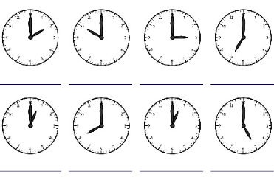
2 o’clock

Languages – Turkish – Miss Figen will be on Webex from 2-3pm if you need any help with this lesson
SHAPES -ŞEKİLLER
By Figen Hasimoglu, MHPS Turkish- Languages Term 3 2020
Please send your child’s work to: Figen.hasimoglu@education.vic.gov.au

What Am I Looking For
- Watch the video clip from the following link
https://www.youtube.com/watch?v=AyrJTJu6wDg
- Colour the picture by using shape colours on page 2.
- Write the Turkish names of the pictures by looking at the shapes and their names below.

We Are Learning To
Identify the shapes in Turkish.

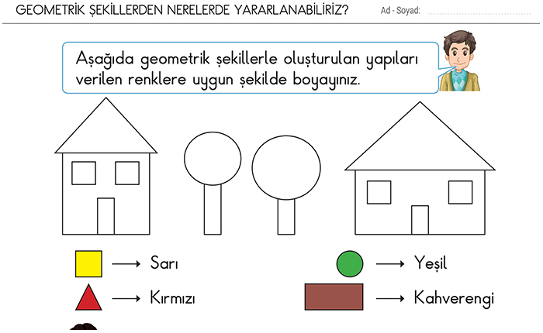

Kare | Daire | Üçgen | Dikdörtgen




