Green Group Thursday
Literacy
Copy handwriting in your workbooks and write 10 words beginning with Hh. Draw a picture for each word.
Today is Thursday the 23rd of July 2020
H H H H H H H H H H
h h h h h h h h h h h h
Harry the hippo and Helen the horse were hungry so they ate ten hamburgers. They were no longer hungry.

Numeracy
10 | 20 | 30 | 40 | 50 | 60 | 70 | 80 | 90 | 100
110 | 120 | 130 | 140 | 150 | 160 | 170 | 180 | 190 | 200

30 | 40

10 | 20

20 | 30

50 | 60

40 | 50

70 | 80

60 | 70
LANGUAGES With Miss Figen
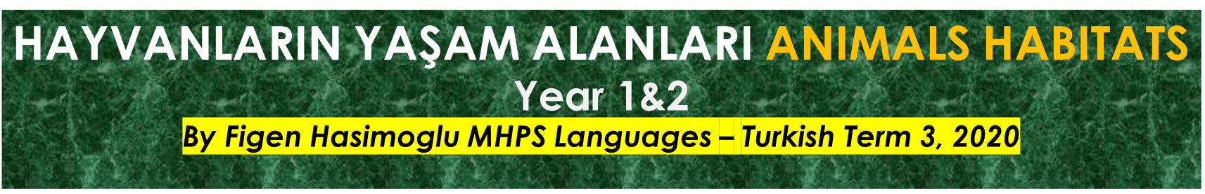
Merhaba Çocuklar (Hello Children), Today
We Are Learning To
- Sing a song called
What I am looking for
- Watch the video clip from the following link:
- https://www.youtube.com/watch?v=Xj1ASC-TlsI
- Copy the next page
- Draw a picture for each habitat.
- Translate the names of the animals into Turkish by using one of the following applications:
- Translate.google.com
- www.seslisozluk.net

